

MAHARASHTRA EDUCATION SOCIETY'S

(SINCE 1860)

**INSTITUTE OF MANAGEMENT & CAREER COURSES (IMCC)**

Approved by AICTE and Recognized by Savitribai Phule Pune University, Pune

IMCC Campus, 131, Mayur Colony, Kothrud, Pune 411038, Maharashtra, India | Ph.: 020-2546 6271 / 73 | e-mail: [info.imcc@mespune.in](mailto:info.imcc@mespune.in) | [http://imcc.mespune.in](http://www.mesimcc.org/)

**NAAC Accredited with Grade A+**

Ref. No.: MES IMCC/ 358 /2024-25 Date: 16/ 04/ 2025

**CERTIFICATE**

This is to certify that the Project entitled **“BlockVote**“ is completed by **“Anis Yasin Khan**” of M.C.A. Semester II for the Academic Year 2024-25 at Maharashtra Education Society's Institute of Management & Career Courses (IMCC), Pune - 411038.

To the best of our knowledge, this is an original study done by the said student and important sources used by him/her have been duly acknowledged in this report.

The report is submitted as a part of course ITP21 Mini Project for the Academic Year 2024-25 as per the rules and guidelines prescribed by the institute.

  

Ms. Kalpana Dhende Ms. Manasi Shirurkar Dr. Ravikant Zirmite

Project Coordinator Program Coordinator Head, Dept. Of MCA



MAHARASHTRA EDUCATION SOCIETY'S

(SINCE 1860)

**INSTITUTE OF MANAGEMENT & CAREER COURSES (IMCC)**

Approved by AICTE and Recognized by Savitribai Phule Pune University, Pune

IMCC Campus, 131, Mayur Colony, Kothrud, Pune 411038, Maharashtra, India | Ph.: 020-2546 6271 / 73 | e-mail: [info.imcc@mespune.in](mailto:info.imcc@mespune.in) | [http://imcc.mespune.in](http://www.mesimcc.org/)

**NAAC Accredited with Grade A+**

Ref. No.: MES IMCC/ 358 /2024-25 Date: 16/ 04/ 2025

**CERTIFICATE**

This is to certify that the Project entitled **“BlockVote**“ is completed by **“Yash Rajendra Gurharikar**” of M.C.A. Semester II for the Academic Year 2024-25 at Maharashtra Education Society's Institute of Management & Career Courses (IMCC), Pune - 411038.

To the best of our knowledge, this is an original study done by the said student and important sources used by him/her have been duly acknowledged in this report.

The report is submitted as a part of course ITP21 Mini Project for the Academic Year 2024-25 as per the rules and guidelines prescribed by the institute.

  

Ms. Kalpana Dhende Ms. Manasi Shirurkar Dr. Ravikant Zirmite

Project Coordinator Program Coordinator Head, Dept. Of MCA

**BlockVote -**

**Secure Blockchain Voting System**

## **A SYNOPSIS OF MINI PROJECT**

***Submitted by***

**Mr. Anis Khan - 2401098**

**Mr. Yash Gurharikar - 2401064**

### ***Under the guidance of***

**Dr.Mukul Kulkarni - Asst Prof MCA**

***in partial fulfillment for the award of the degree of***

**MASTER IN COMPUTER APPLICATION**

**AT**



**Department of MCA**

**INSTITUTE OF MANAGEMENT & CAREER COURSES**

**PUNE**

**Title of the project: BlockVote**

**Objectives of the Blockchain E-Voting System:**

1. **To develop a secure and transparent e-voting platform using blockchain technology.**  
   The primary aim is to eliminate traditional vulnerabilities like vote tampering, double voting, or unauthorized access.
2. **To ensure voter authentication and privacy.**  
   Implement mechanisms for verifying voter identity while maintaining the confidentiality of individual votes.
3. **To enable decentralized and tamper-proof storage of votes.**  
   Use blockchain's immutable ledger to store votes, ensuring that once cast, a vote cannot be altered or deleted.
4. **To reduce reliance on central authorities or intermediaries.**  
   Design the system such that no single entity controls the voting process, increasing trust among participants.
5. **To improve accessibility and convenience in the voting process.**  
   Allow eligible voters to cast their votes remotely from any location, increasing participation.
6. **To provide real-time vote counting and result generation.**  
   Ensure accurate and transparent counting of votes with instant result updates.
7. **To explore the practical implementation of smart contracts in electoral systems.**  
   Automate key processes (like vote validation or result calculation) using smart contracts to minimize human intervention.
8. **To design a user-friendly interface for both administrators and voters.**  
   Build an intuitive front-end for easy interaction with the blockchain backend.

**Scope:-**

**The Blockchain E-Voting System aims to transform the traditional voting process by leveraging the key features of blockchain technology—decentralization, transparency, immutability, and security. The scope of this project includes both the technical and functional aspects required to conduct a secure and efficient electronic voting process.**

**In Scope:**

1. **Voter Registration & Authentication  
   A secure system for registering voters and validating their identity before allowing them to vote.**
2. **Admin Panel  
   A dashboard for election administrators to add candidates , voters , set up elections, and monitor the voting process.**
3. **Voting Mechanism on Blockchain  
   Implementation of a smart contract that records each vote on the blockchain, ensuring it is immutable and verifiable.**
4. **User Interfaces (UI) for Admin and Voters  
   A clean, user-friendly web interface for both voters (to view candidates and results ) and admins (to manage the election).**
5. **Real-Time Vote Tallying and Result Display  
   Votes are counted automatically and results are made available in real-time with complete transparency to Admins .**
6. **Smart Contract Integration  
   Usage of smart contracts for automating , storing votes, and declaring results.**
7. **Conducting multiple elections concurrently.**

**Out of Scope:**

1. **Offline Voting  
   The system is intended for online use only and does not support offline/physical voting methods.**

**Future Scope:**

1. **Nationwide Implementation**

**The system can be scaled to support national and state-level elections, replacing or supplementing traditional voting systems to increase transparency and accessibility.**

1. **Integration with Digital Identity Systems**

**Can be integrated with Aadhaar (India), e-ID or other government ID verification systems for secure voter authentication and to prevent impersonation.**

1. **Hardware Device to scan QR or Barcode**

**The system can be enhanced by integrating hardware-based QR code scanners for fast and secure voter authentication, reducing manual entry errors and streamlining the login process at physical polling booths.**

Flow chart:

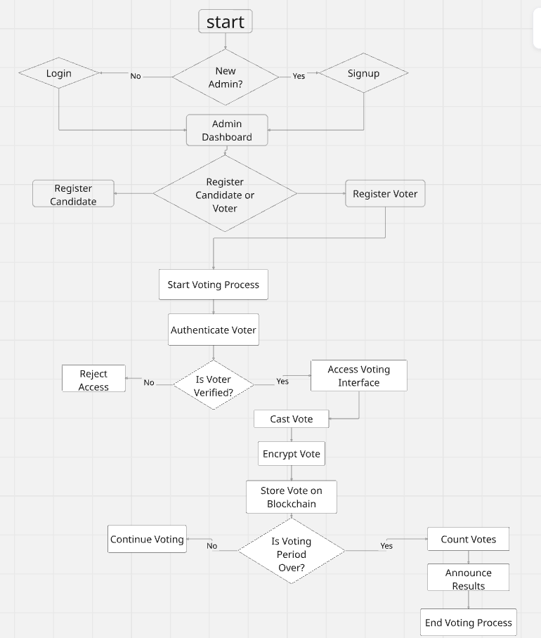

**ER Diagram:-**

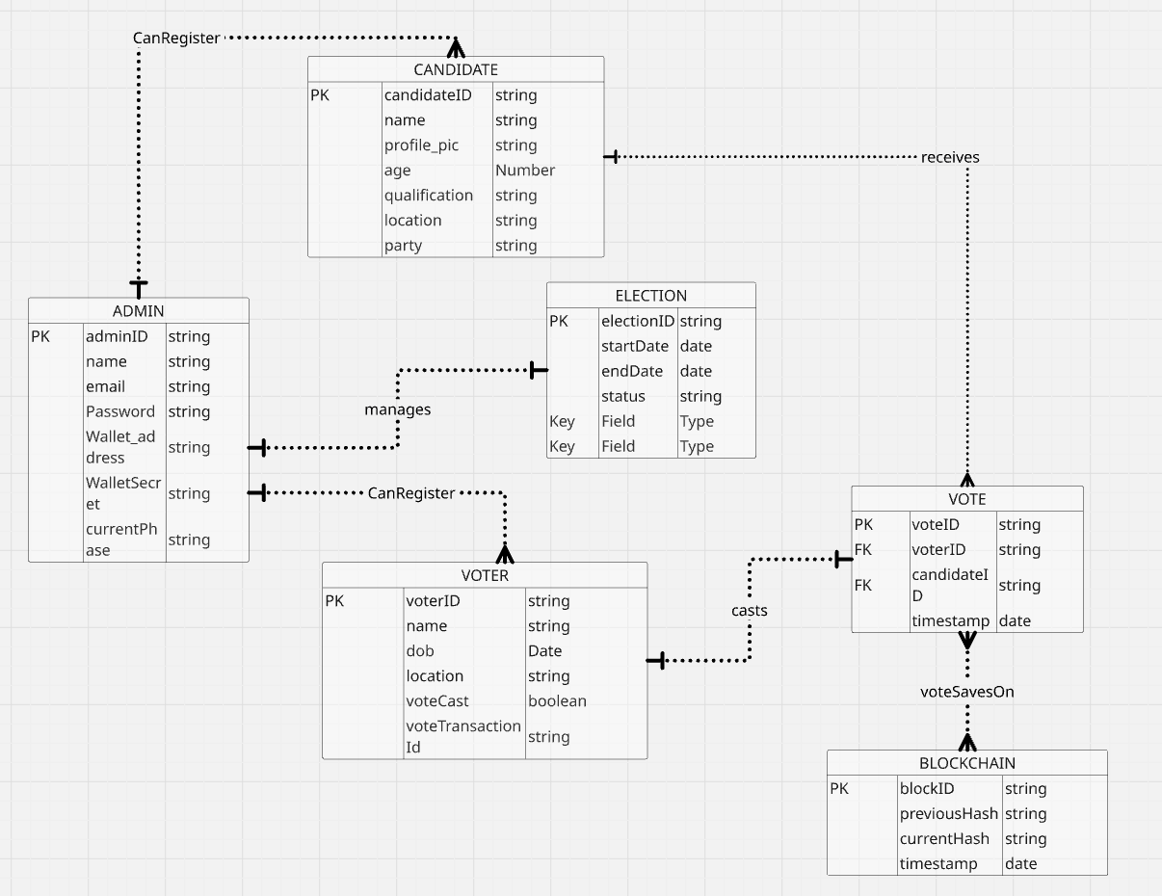

**Usecase Diagram:-**

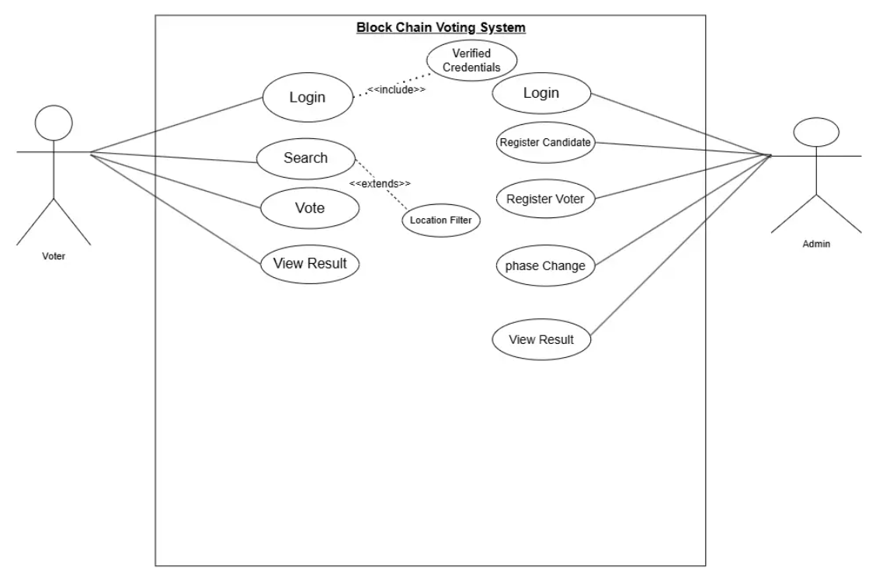

**Data dictionary:-**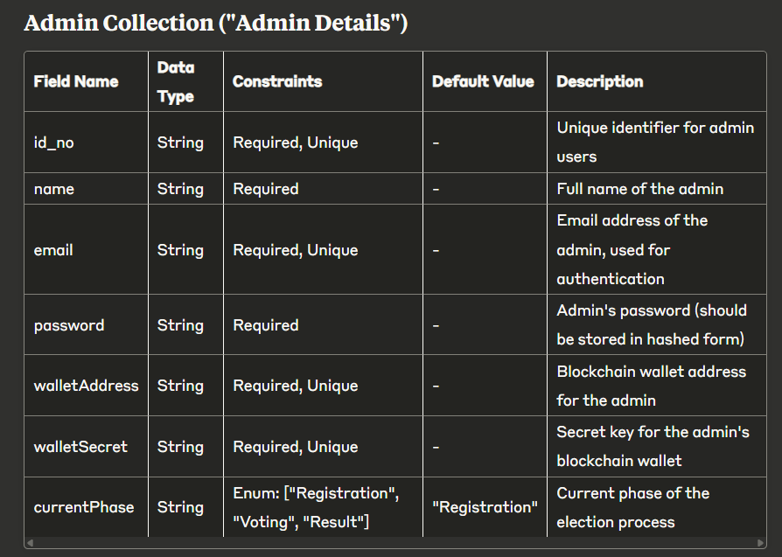

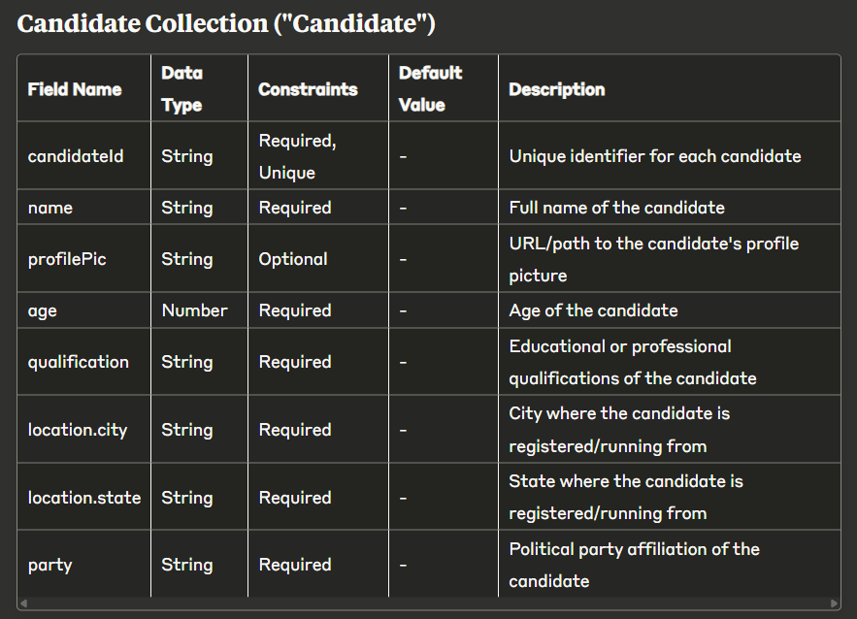

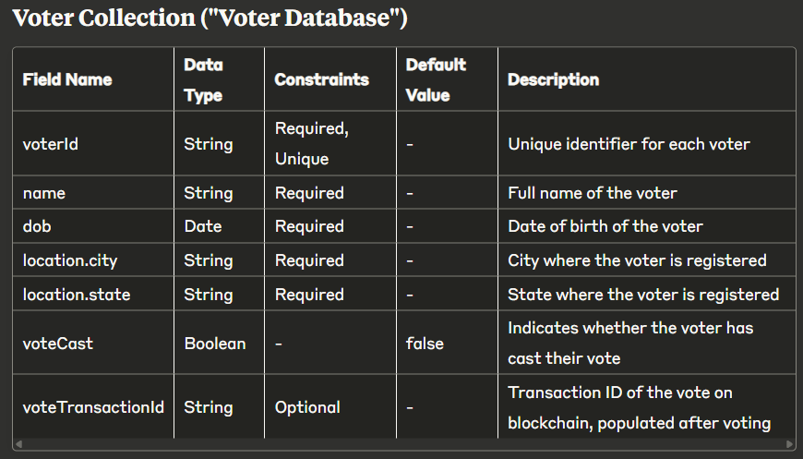

**Output Screenshot:**

**Hosted on AWS ( Amazon Web Services )**

**Website URL :-**

<https://blockvote.site/>

Landing Page

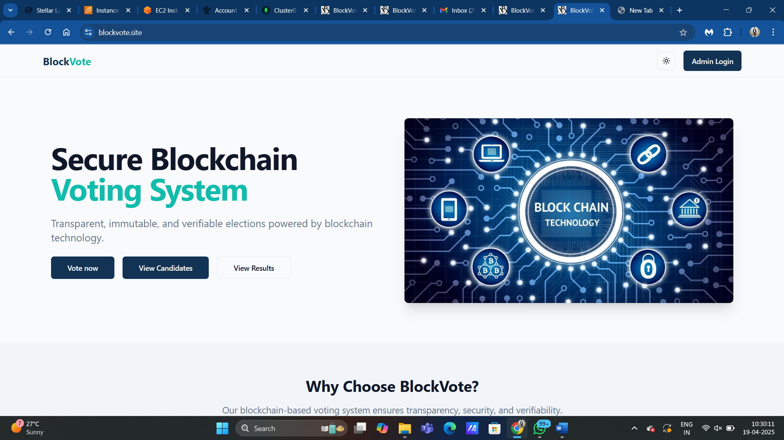



**Landing Page**

**Description:**  
This page serves as the welcome and navigation interface for all users—admins, voters, and public viewers. It introduces the purpose of the BlockVote system and allows users to select their role.

**Key Features:**

**Navigation Panel:**

* Admin Login button directs administrators to the login interface.
* Voter Login button for voters to authenticate and vote.
* Public Results button for anyone to view live or finalized results.

**System Overview:**

* A brief introduction to what BlockVote is and how blockchain ensures secure voting.
* Call-to-action text encouraging transparency and decentralized voting.

**Design & Accessibility:**

* Fully responsive layout optimized for mobile and desktop.
* Clear font and iconography for easy usability.

**Validation & Security:**

* No input fields on this page, hence no active validation.
* Secure routing ensures navigation to authenticated zones only.

Admin Registration

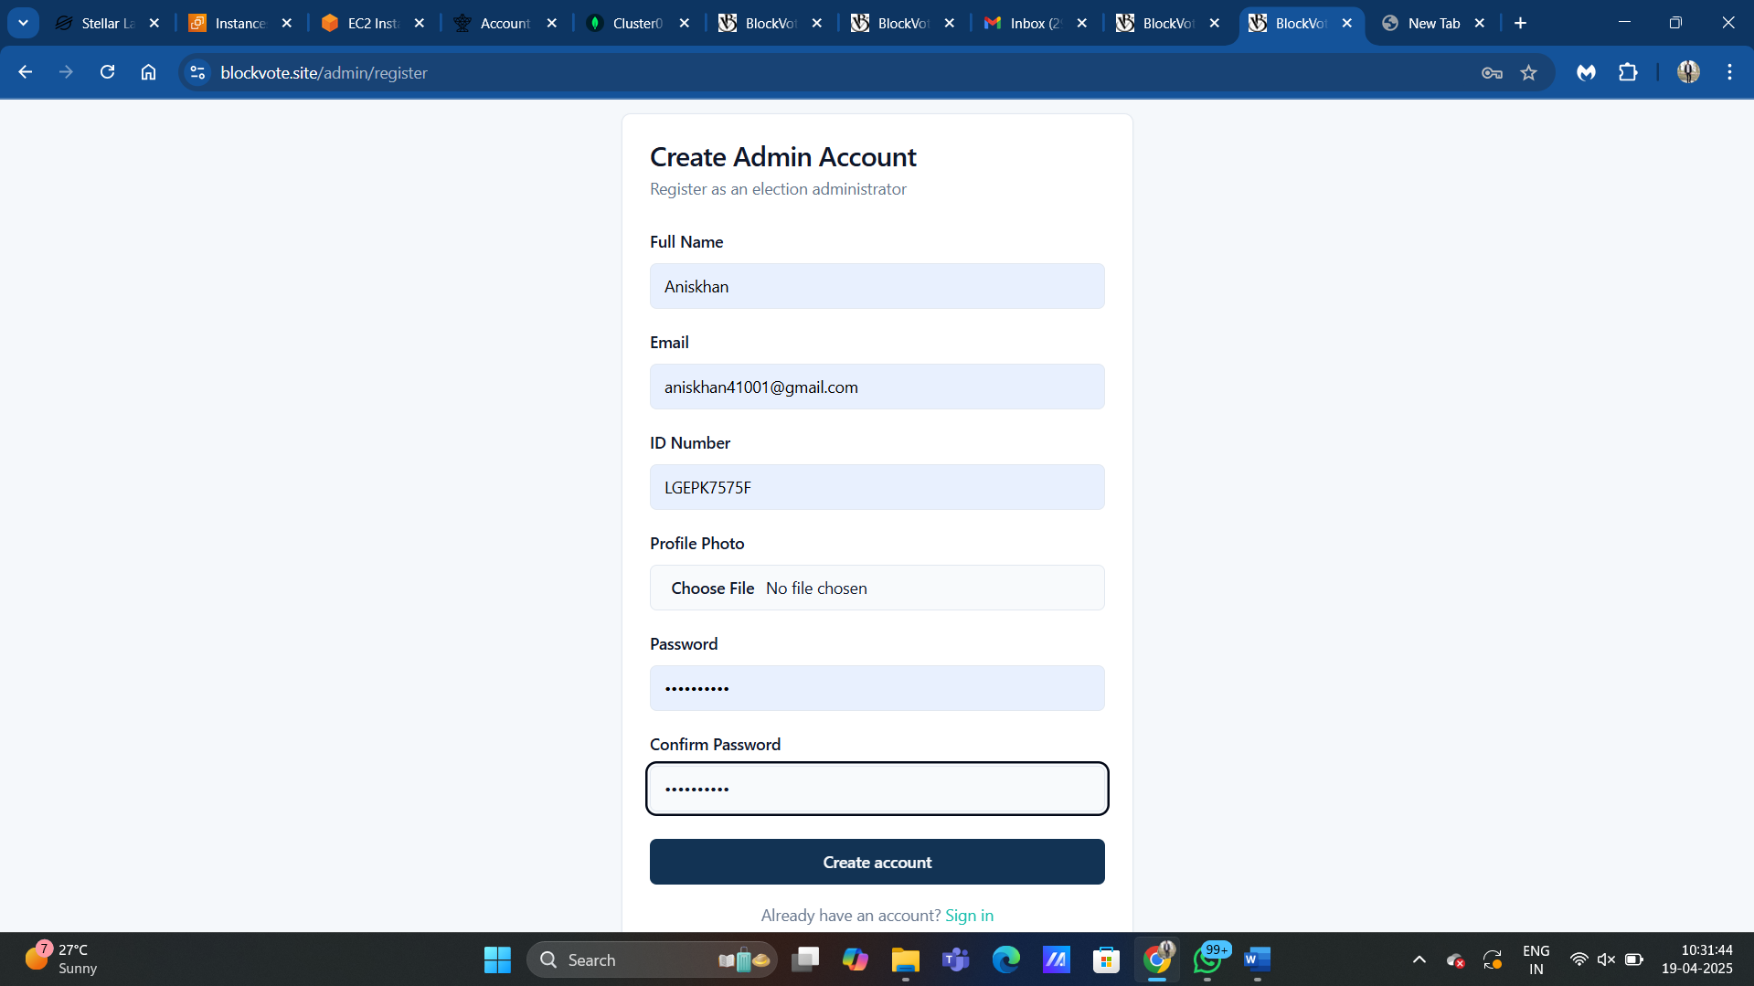

**Admin Registration Page**

**Description:**  
This page allows new election administrators to securely create an account with validated credentials, which are necessary to manage the election process.

**Key Features:**

**Input Fields:**

* **Name:** Must be a non-empty alphabetic string.
* **Email:** Must follow a valid email format (example@domain.com) and must be unique in the system.
* **Password:** Minimum of 8 characters;
* **Confirm Password:** Must match the Password field exactly.

**Validation Rules:**

* Real-time frontend validation with visual feedback.
* Backend validation includes email uniqueness check and password hashing.
* All fields are mandatory; form cannot be submitted until validation passes.

**Security Measures:**

* Passwords are encrypted using bcrypt or a similar hashing algorithm before storing in the database.
* Data transmission occurs over HTTPS to ensure data integrity and confidentiality.
* Email validation ensures that no duplicate or fake accounts are registered.

**User Feedback:**

* Inline error messages are displayed beside each field when invalid data is entered.
* A success toast or redirect occurs upon successful registration

Admin Login

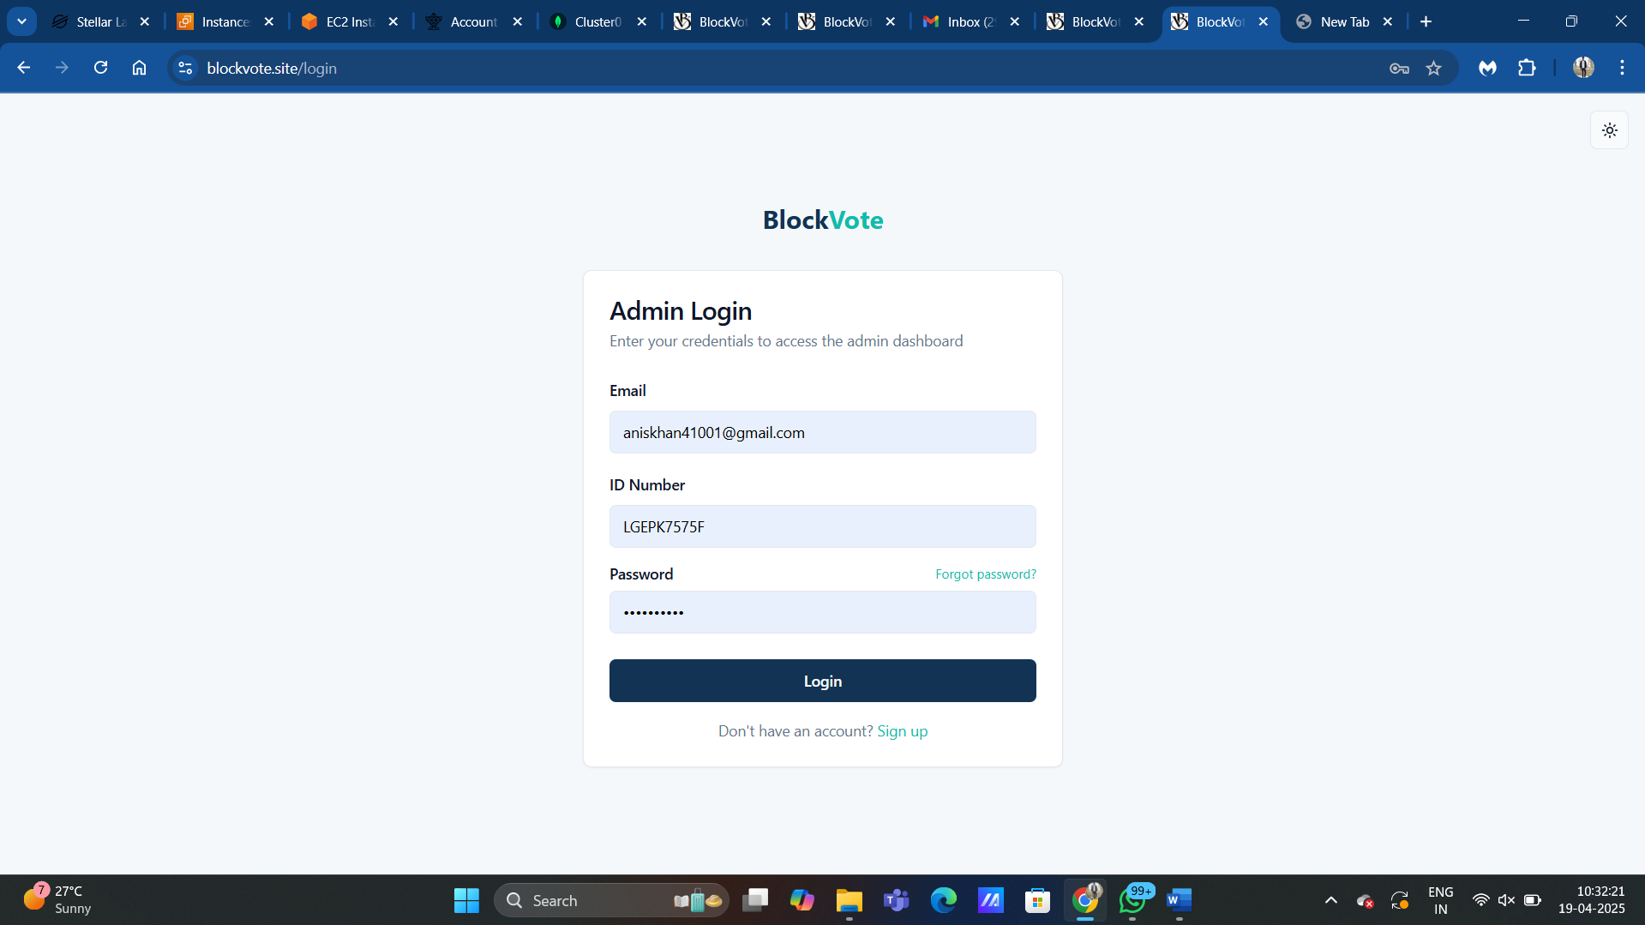

**Admin Login Page**

**Description:**  
This page allows previously registered admins to securely log into their accounts to manage election settings and monitor progress.

**Key Features:**

**Input Fields:**

* **Email:** Must match a registered admin account and follow standard email format.
* **Id card no :** Must match a Registed admin account
* **Password:** Must match the password associated with the entered email.

**Validation Rules:**

* All fields required; empty fields prevent submission.
* Backend checks if the email exists and if the password is correct.

**Security Measures:**

* Password is encrypted and matched using secure hashing methods.
* Tokens (JWT) generated upon successful login for session authentication.

**User Feedback:**

* Invalid login attempt shows “Incorrect email or password.”
* Successful login redirects to the Admin Dashboard.

Otp Verification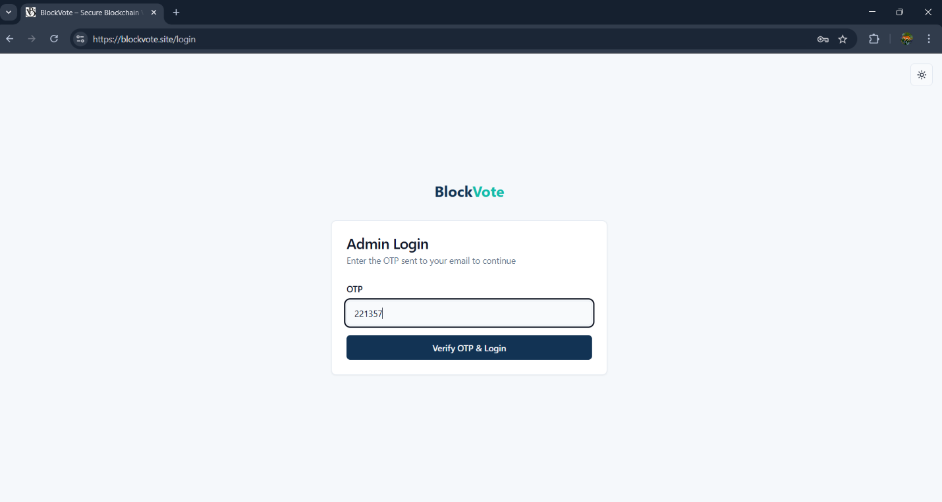

**OTP Verification Page**

**Description:**  
After login or before critical actions like phase change, admins must enter a One-Time Password sent to their email to verify identity.

**Key Features:**

**Input Fields:**

* **OTP:** 6-digit numeric code that must be entered within a time limit (typically 5 minutes).

**Validation Rules:**

* OTP must match the code sent to the admin’s registered email.
* Expired OTPs will not be accepted; users must request a new one.

**Security Measures:**

* OTP is stored temporarily in backend memory (like Redis) and deleted after use.
* Sensitive actions (like phase changes) cannot proceed without successful OTP verification.

**User Feedback:**

* Correct OTP redirects user to next action.
* Incorrect OTP triggers “Invalid or expired code” warning.

**Forgot password**

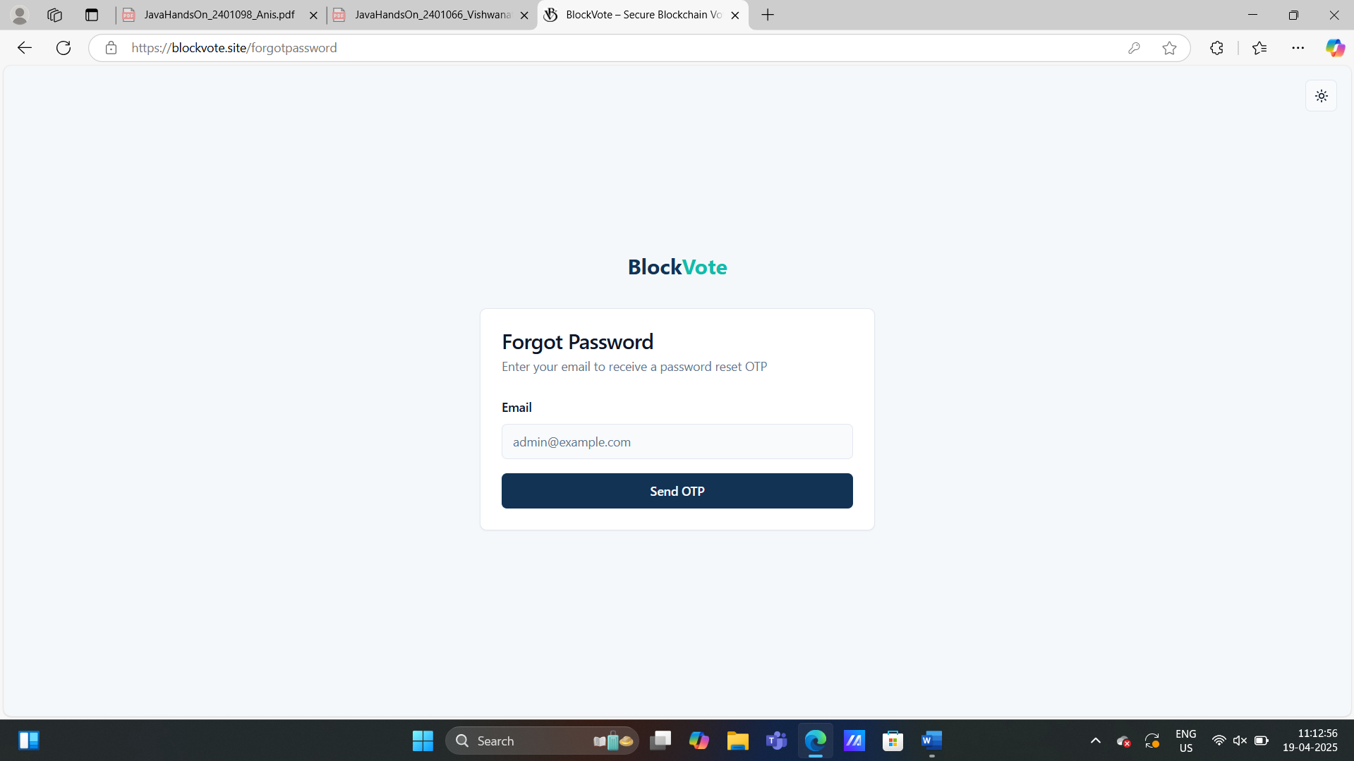

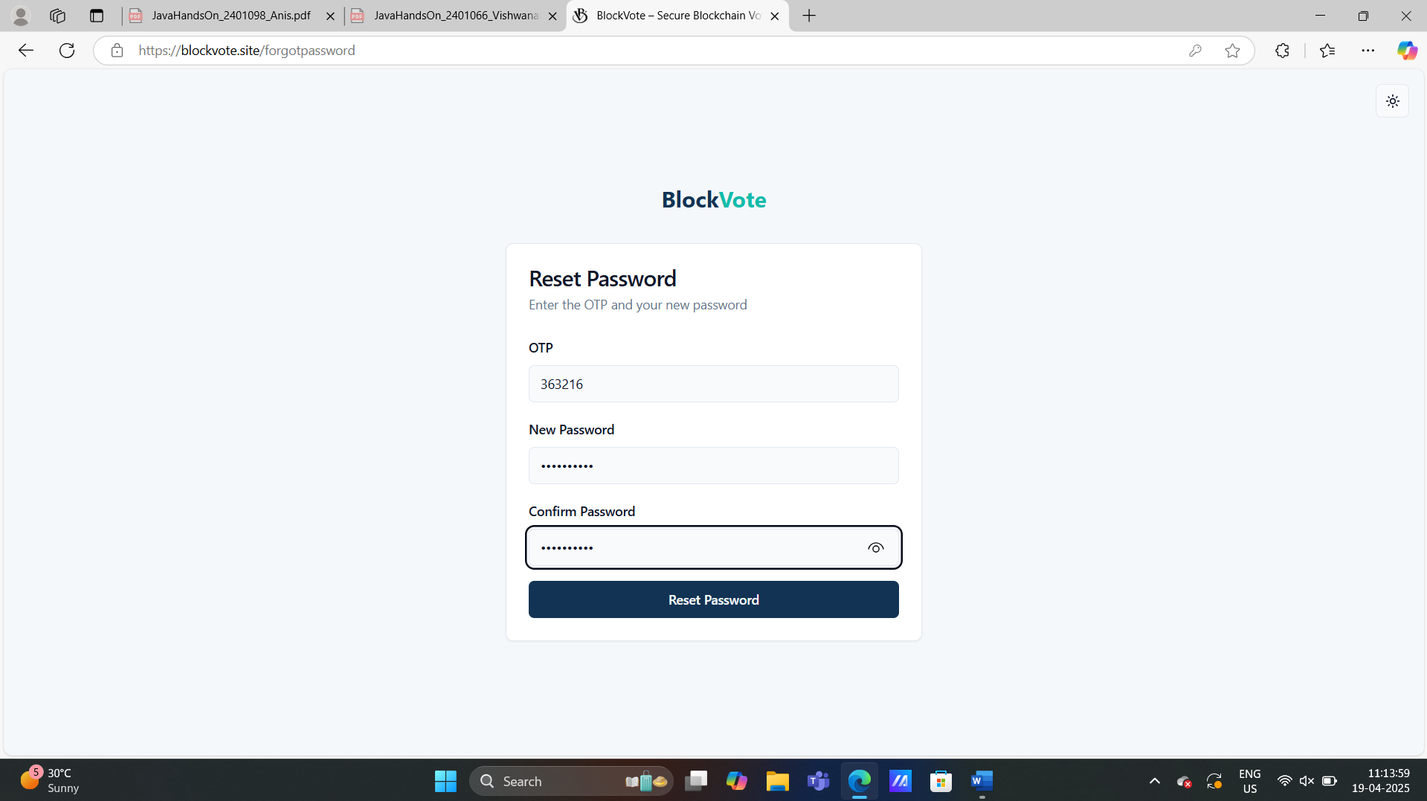

**Forgot Password (with OTP Verification)**

**Description:**  
This feature allows admins who have forgotten their password to reset it securely. The process includes identity verification via a One-Time Password (OTP) sent to their registered email before allowing password reset.

**Key Features:**

**Step 1: Request Password Reset**

* **Input Field:** Admin enters their registered email address.
* **Send OTP Button:** Triggers the backend to generate and send an OTP to the entered email.
* **Validation:**
  + Email must be in valid format (e.g., user@example.com).
  + Must be associated with an existing admin account.
  + If not found, shows: “Email not registered.”

**Step 2: OTP Verification**

* **OTP Field:** Numeric-only 6-digit input.
* **Resend OTP:** Button appears after a 30-second cooldown to generate a new OTP.
* **Validation:**
  + OTP must match the backend record.
  + OTP expires in 5 minutes from generation.
  + Max 3 attempts allowed; after that, the OTP is invalidated.
  + Field allows only numeric input.

**Step 3: Set New Password**

* **New Password Field:** Must follow strong password rules.
* **Confirm Password Field:** Must match the New Password.
* **Validation Rules:**
  + New password must be at least 8 characters, including one uppercase letter, one number, and one special character.
  + Confirm Password must match exactly.
  + Backend checks that the new password is not the same as the previous password (if enforced).

**Security Measures:**

* OTP is securely generated using random number generator and temporarily stored (e.g., Redis) with a time-to-live (TTL).
* OTP is hashed and not stored in plain text.
* All endpoints are rate-limited to prevent brute-force attempts.
* Password is encrypted using strong hashing algorithms like bcrypt before storing.
* Successful password reset invalidates all previously issued login tokens for the admin.

**User Feedback:**

* **After Sending OTP:** “OTP has been sent to your registered email.”
* **On OTP Success:** “OTP verified. You can now reset your password.”
* **On OTP Error:** “Invalid or expired OTP. Please try again.”
* **On Password Reset:** “Password reset successful. Please log in with your new password.”
* **On Error:** “Something went wrong. Please try again later.”

Admin Profile

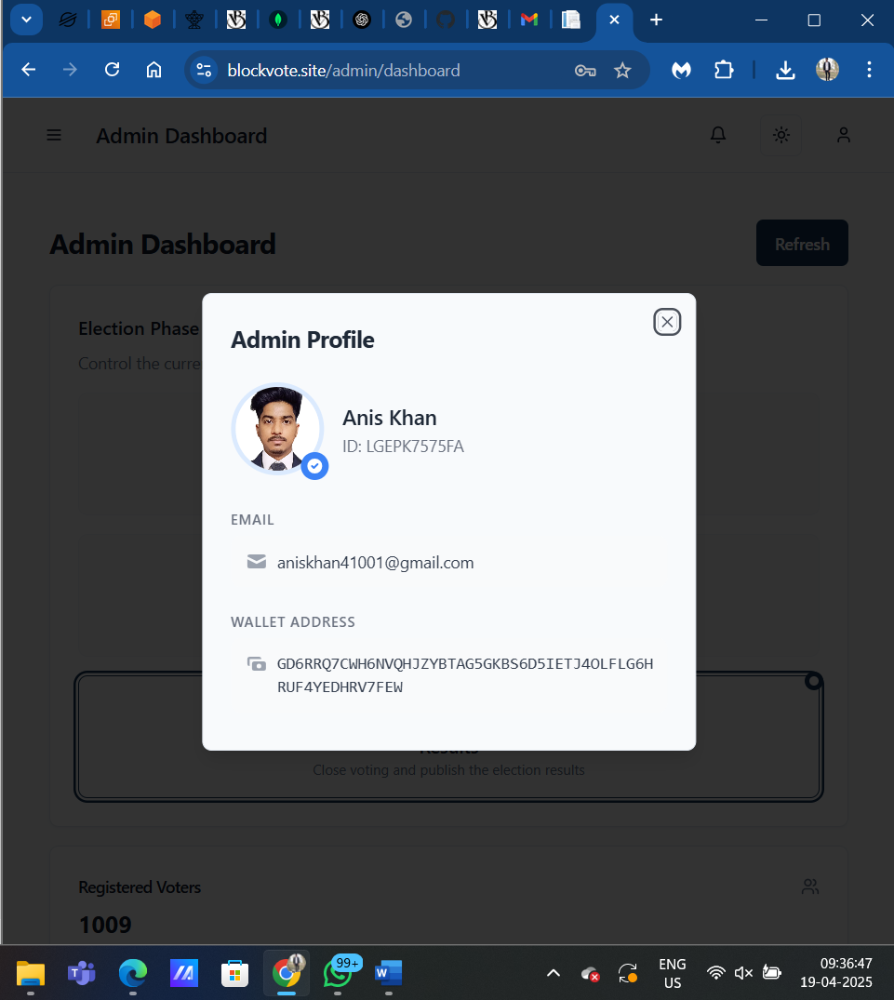

**Admin Information:**

* **Full Name:** Displays the name used during registration.
* **Email Address:** Shows the admin’s registered and verified email.
* **Admin ID:** Unique identifier for tracking and audit logs.
* **Profile Photo:** Display profile photo.

**Security Measures:**

* All updates are authenticated using JWT token.
* Sessions are tracked and secured via Redis or session management middleware.
* Passwords encrypted using hashing algorithms like bcrypt.

Admin Dashboard

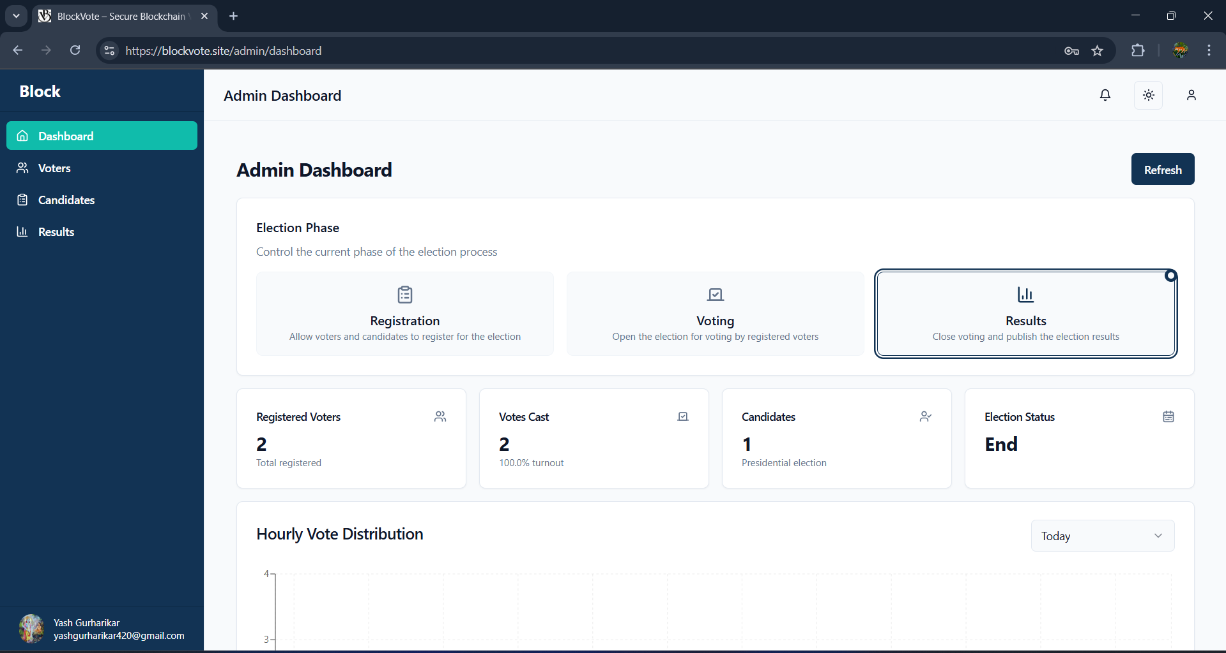

**Admin Dashboard**

**Description:**  
The central control panel for the admin, offering access to election setup, phase control, voter/candidate registration, and analytics.

**Key Features:**

**Dashboard Overview:**

* Displays metrics: total voters, candidates, votes cast, and current election phase.
* Quick navigation to all major functions.

**Navigation Modules:**

* Register Voter
* Add Candidates
* Change Election Phases
* View Voting Statistics

**Security Controls:**

* Admin-only access with token-based authentication.
* Actions logged with timestamps and admin ID.

**Validation Rules:**

* Controls/buttons are enabled/disabled based on current election phase.
* Data fetched via protected API endpoints.

**User Feedback:**

* Toast messages for success/failure on all actions.
* Live updates for phase status and voting stats.

Phase change to registration(Otp verification)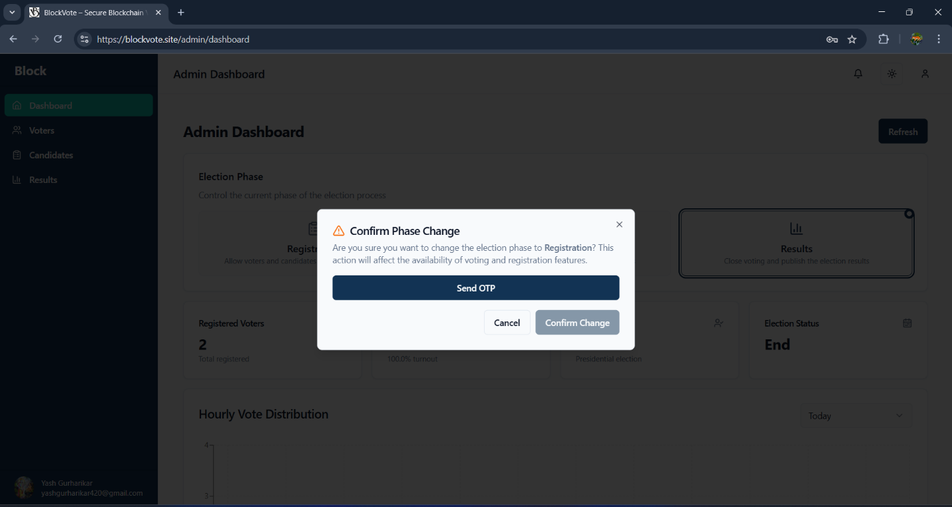

**Phase Change to Registration (OTP Verification)**

**Description:**  
A secure confirmation step that allows admins to move the system into the voter registration phase, after entering OTP.

**Key Features:**

**OTP Authentication:**

* 6-digit code sent to admin’s email for verification before changing the phase.

**Phase Control Mechanism:**

* Changes system state from “Not Selected” to “Registration” phase.

**Validation Rules:**

* OTP must be entered correctly within 5 minutes.
* Only admins can initiate this phase change, and only once per cycle.

**Security Measures:**

* OTP is cleared from memory after use.
* Logs include phase change, admin ID, and exact timestamp.

**User Feedback:**

* Success message after phase change.
* Warning shown if OTP is incorrect or expired.

**Recent Activity Logs Page**

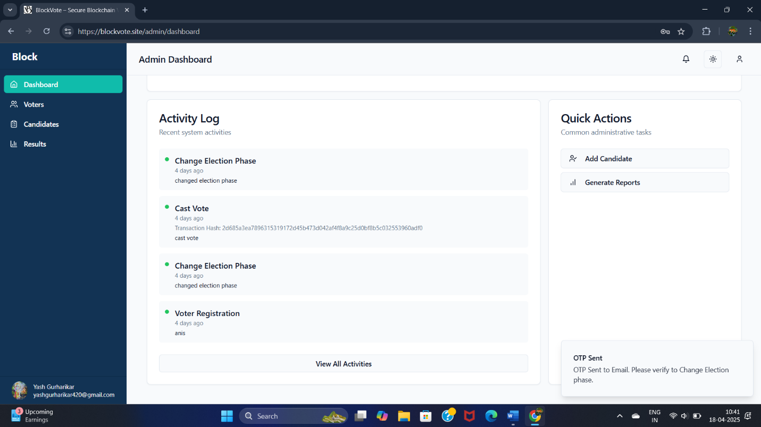

Registering Voters (by filling details manually)

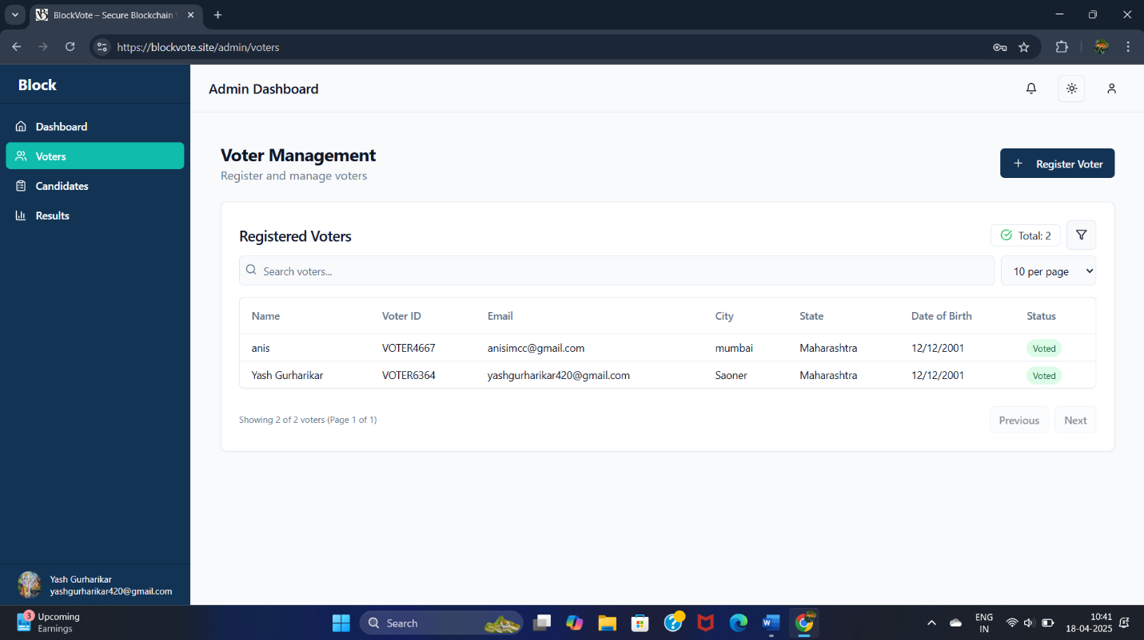

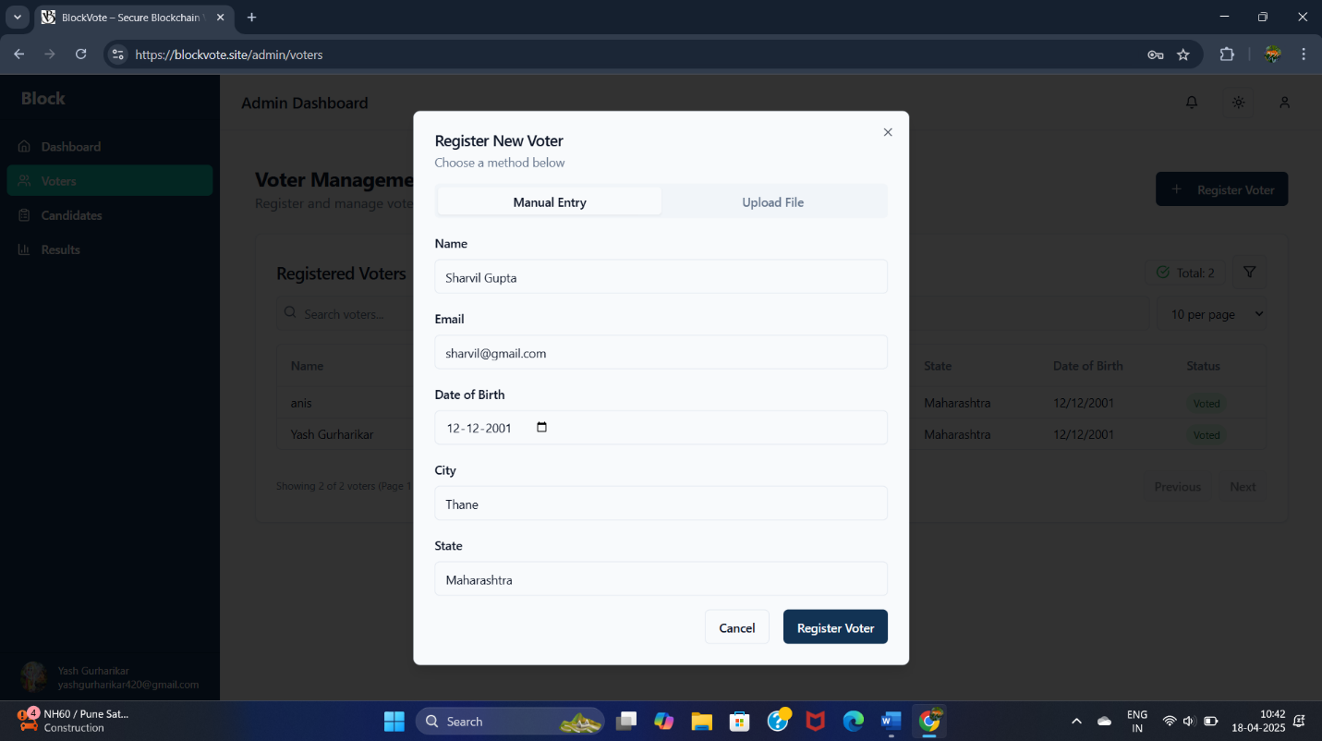

**Registering New Voters (Manually)**

**Description:**  
Admins can manually register individual voters by filling out a form with their basic information.

**Key Features:**

**Input Fields:**

* **Full Name:** Alphabetic, required.
* **Dob:** Date Selection Calendar is displayed
* **Email:** Must be valid and unique.
* **City:** Free text.
* **Phone:** 10-digit Indian phone number.

**Validation Rules:**

* Duplicate voter ID and email are Allowed.
* Age should be Above 18 years
* Empty fields trigger inline errors.
* Phone number must be exactly 10 digits.

**Security Measures:**

* All entries sanitized before saving.
* Data encrypted before being sent to database.

**Email Notification:**

**After successfully Registering the Voter, Voter Get his Voter Id on his Registered Email**

**User Feedback:**

* Form shows “Voter Registered Successfully” on success.
* Errors highlight specific invalid fields.

Registering Voters(by uploading excel sheet)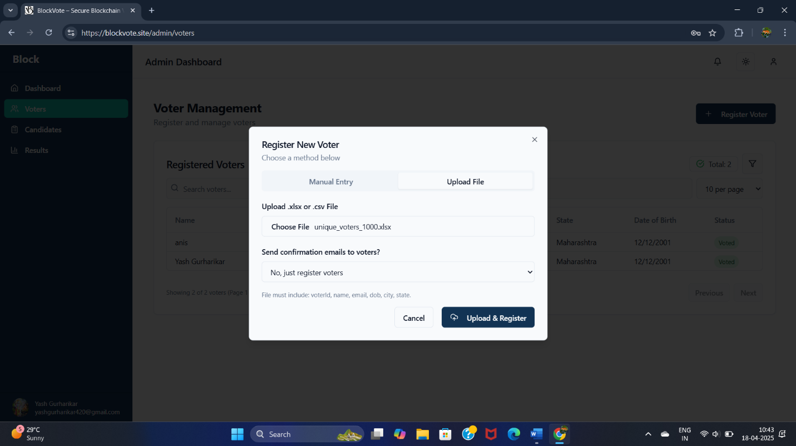

**Registering Voters by Uploading Excel Sheet**

**Description:**  
This feature allows bulk voter registration using a .csv or .xlsx file uploaded by the admin.

**Key Features:**

**File Upload Interface:**

* Upload button supports .csv and .xlsx formats.
* Sample Headers of file is displayed above upload button for correct formatting.

**Validation Rules:**

* Required columns: Name, Email, Voter ID, Phone, City ,State.
* Backend checks for duplicate or invalid entries.
* Errors shown per row if validation fails.

**Security Measures:**

* Sheet is parsed and sanitized server-side.
* Prevents CSV injection and unauthorized file types.

**User Feedback:**

* “Voters Uploaded Successfully” toast message.
* Displays count of successful and failed entries.

Adding Candidates for Election

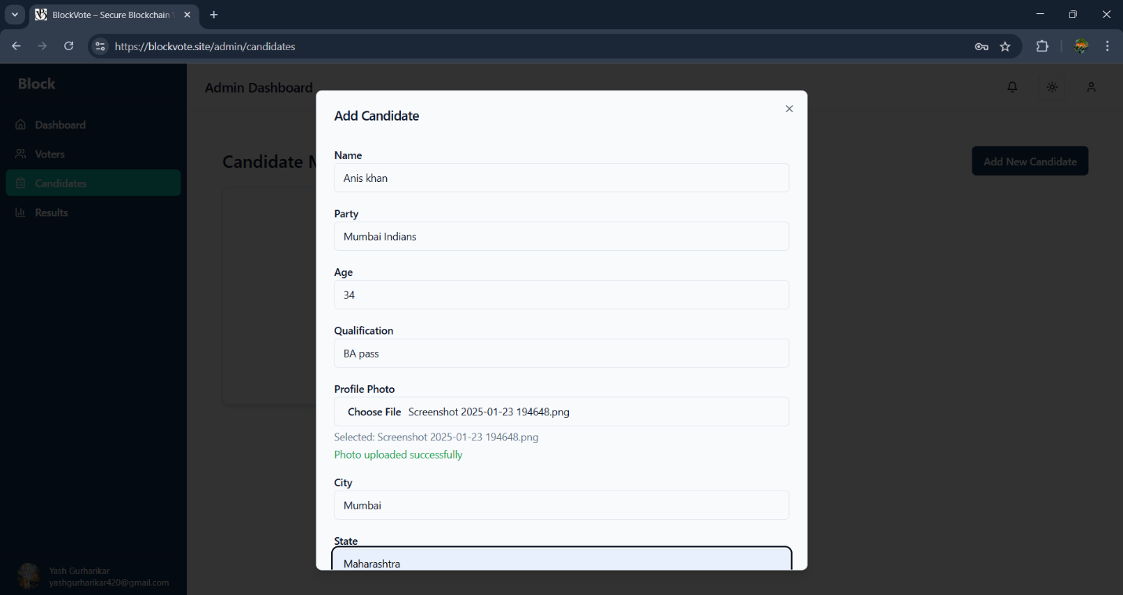

**Adding Candidates for Election**

**Description:**  
Admins can add candidates by entering their personal and professional details through a form.

**Key Features:**

**Input Fields:**

* **Candidate Name:** Alphabetic, required.
* **Age:** Numeric, must be ≥ 18.
* **Qualification:** Text input.
* **Party Name:** Required.
* **Profile Picture:** Image upload (.png/.jpg only).

**Validation Rules:**

* Duplicate entries are blocked.
* File upload must be image type under 10MB.
* Age must be ≥ 18 years.

**Security Measures:**

* Uploaded images are renamed and stored securely.
* All fields sanitized before storing in database.

**User Feedback:**

* Success confirmation message after candidate is added.
* Image preview and error messages for invalid formats.

List of candidates added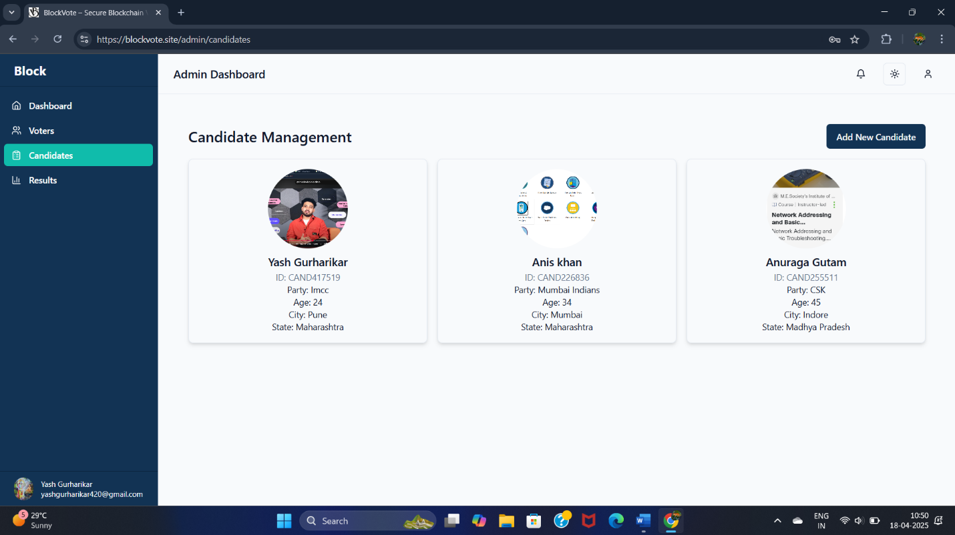

**List of Candidates Added**

**Description:**  
This page displays all candidates added by the admin.

**Key Features:**

**Candidate Table View:**

* Columns include: Candidate Name, Party, Age, Qualification, Profile Picture.
* Visual layout includes candidate photo thumbnails for easy identification.

**Validation Rules:**

* Only candidates from the current election cycle are shown.
* Duplicate names with the same party not allowed.

**Security Measures:**

* All actions require admin authentication.
* Backend checks prevent unauthorized deletion or updates.

Phase change to Voting Phase(Otp verification)

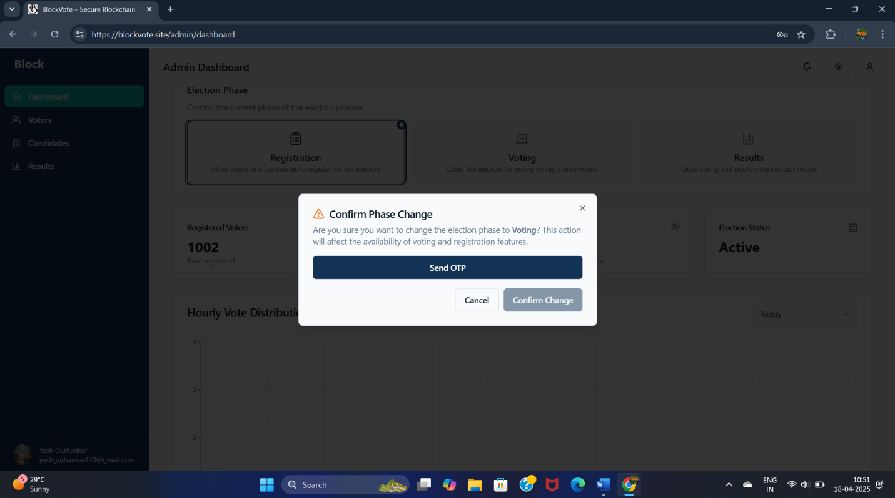

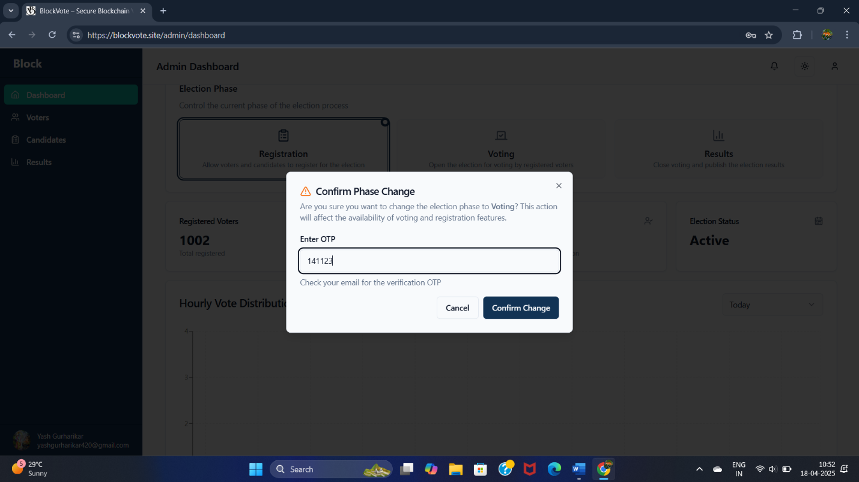

**Phase Change to Voting Phase (OTP Verification)**

**Description:**  
This phase transition marks the end of registration and the beginning of active voting, confirmed with OTP verification.

**Key Features:**

**OTP Input Section:**

* Admin must enter a valid 6-digit OTP sent to their registered email.

**Phase Control Functionality:**

* Once verified, voter access is opened and registration/editing is locked.

**Validation Rules:**

* OTP must match and be valid within a 5-minute window.
* Duplicate phase transitions blocked by backend.

**Security Measures:**

* Logs admin ID, and timestamp.
* OTPs are hashed and stored temporarily.

**User Feedback:**

* Success message: “Voting Phase Started.”
* If expired or wrong OTP: “Invalid OTP. Please try again.”

**Number of logged in Devices**

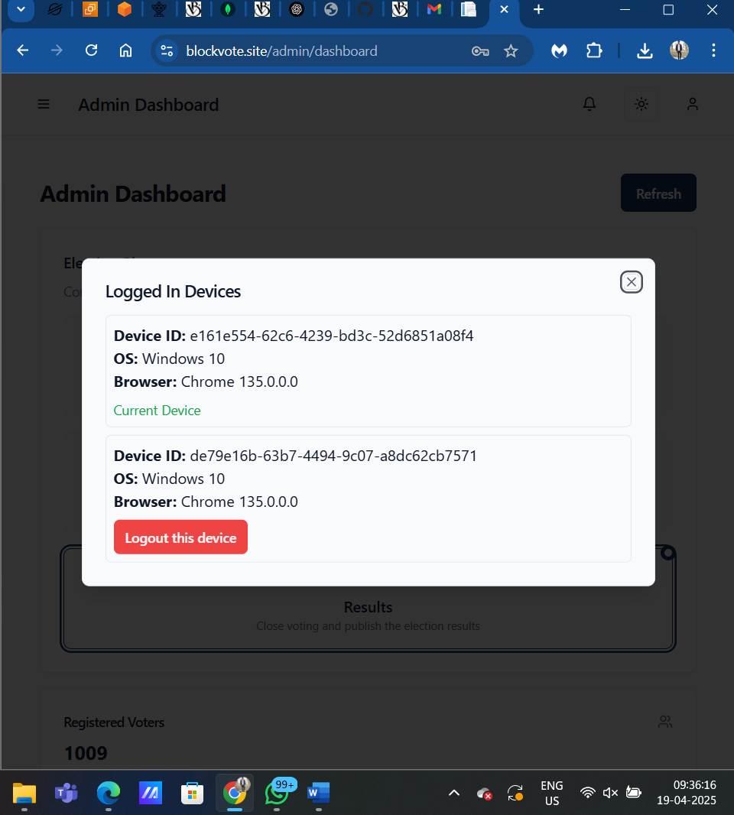

**Logged-in Devices Page**

**Description:**  
This page allows the admin to view all active sessions where their account is currently logged in. It helps the admin monitor device activity and take immediate action on unauthorized access.

**Key Features:**

**Active Sessions Table:**

* **Device ID:** A unique identifier for each session (e.g., authtoken and UUID).
* **Device Info:**
  + **Browser Name:** Chrome, Firefox, Safari, etc.
  + **Operating System:** Windows, Android, iOS, Linux, etc.
* **Login Timestamp:** Shows exact date and time of session creation.
* **Token Preview:** A short version of the authentication token (partially masked for security).

**Action Controls:**

* **Logout Button per Row:** Allows the admin to terminate a specific session/device.
* **Logout All Devices:** One-click button to invalidate all tokens except the current session.

**Validation Rules:**

* **Token Validation:** Ensures the session being revoked is valid, not expired, and matches a real login session.
* **Current Session Protection:** The admin cannot accidentally log themselves out from the session they are currently using.

**Security Measures:**

* All requests are authenticated via JWT token.
* Logging out a device removes its token from Redis or session store.
* Action logs (admin ID, IP, and time) are stored for auditing.
* Secure confirmation dialogs before logging out sessions.
* Tokens cannot be reused once revoked.

**User Feedback:**

* Confirmation prompt: “Are you sure you want to log out this device?”
* Toast message after success: “Device logged out successfully.”
* In case of failure: “Session not found or already expired.”
* Visual indicator for **current device** (e.g., “This device” badge or icon).

**Verify Logout**

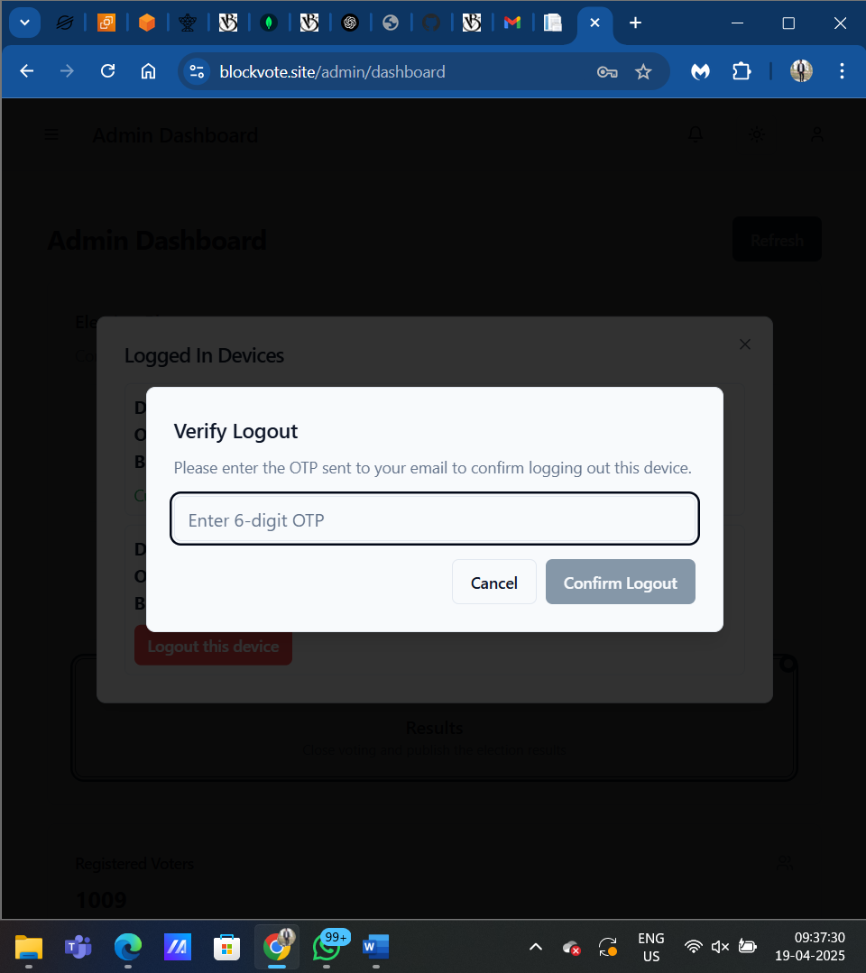

**Verify Logout (with OTP Verification)**

**Description:**  
This secure logout verification dialog appears when the admin attempts to log out from a device. It requires the admin to enter a One-Time Password (OTP) sent to their registered email before the session is terminated. This adds an extra layer of protection to prevent unauthorized session revocation.

**Key Features:**

**Confirmation Dialog:**

* Title: **“Confirm Logout of Device”**
* Message: Clearly informs the admin about the consequences of logging out.
* Contextual Details: Displays partial device info (e.g., “Chrome on Windows - Logged in on 17-Apr-2025”).

**OTP Input Field:**

* Field to enter the 6-digit OTP code received via email.
* “Resend OTP” option available after 30 seconds cooldown.
* Masked OTP input with numeric-only validation.

**Target Options:**

* **Logout This Device**
* **Logout Other Device**

**Validation Rules:**

**OTP Validations:**

* Must be a 6-digit numeric code.
* Must match the one sent to the admin's registered email.
* OTP expires in 5 minutes from time of generation.
* Only 3 attempts allowed per OTP; then re-verification is required.

**Session Validations:**

* Device token/session ID must match an active device linked to the admin.
* Cannot log out the current session without proper OTP and admin re-authentication.

**Security Measures:**

* OTP is generated using a secure random generator and stored in cache (e.g., Redis) with TTL (Time To Live).
* Token comparison is done using time-safe algorithms to prevent timing attacks.
* Once OTP is used or expired, it is invalidated immediately.
* Logs each logout action (admin ID, device info, timestamp, IP address).

**User Feedback:**

* **On Success:** “Device has been successfully logged out.”
* **On OTP Error:** “Invalid or expired OTP. Please try again.”
* **On Server Error:** “Logout request failed. Please try again later.”
* Visual feedback on OTP resend countdown and input validation.

Voter Login (Voter verification)

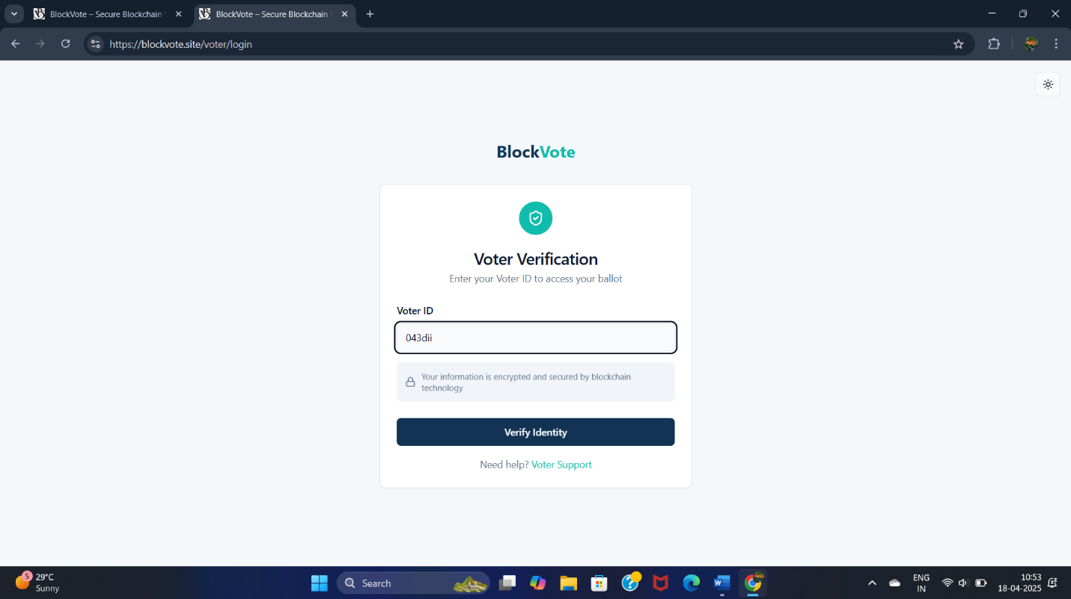

**Voter Login (Voter Verification)**

**Description:**  
Registered voters use this page to log in by entering their voter ID on Voting Booth.

**Key Features:**

**Important Update : Admin Login is Required in Backend Means Voting Can only be done on Admin PC.**

**Input Fields:**

* **Voter ID:** Must match a registered ID.

**Validation Rules:**

* Invalid voter ID triggers “Not registered” message.

**Security Measures:**

* One vote allowed per verified voter session.

**User Feedback:**

* On success: “Welcome! Proceed to vote.”
* On failure: error message with retry option.

**Voting page(select candidate and vote)**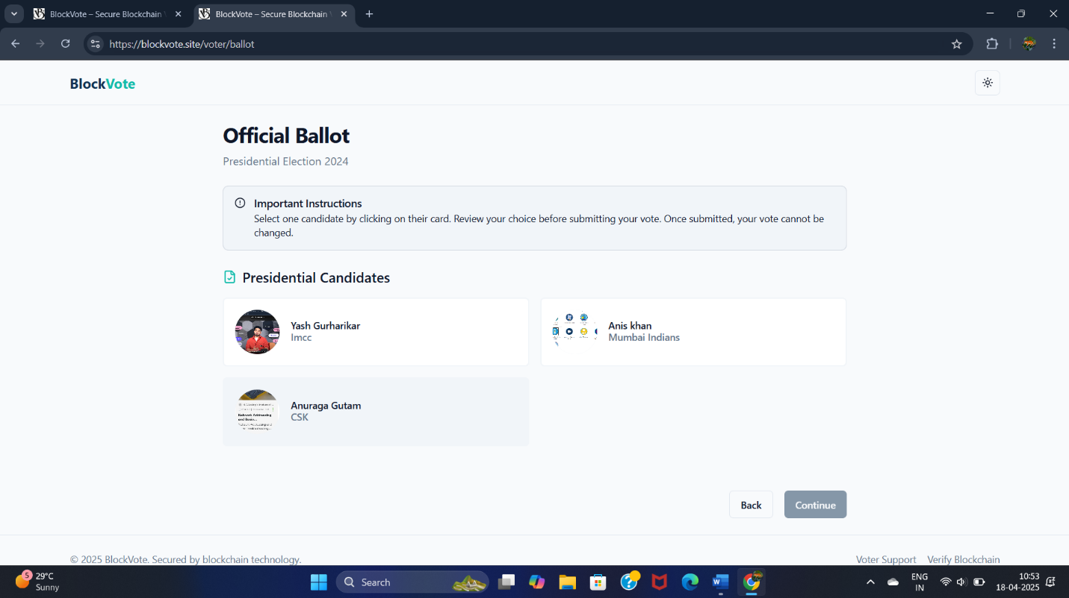

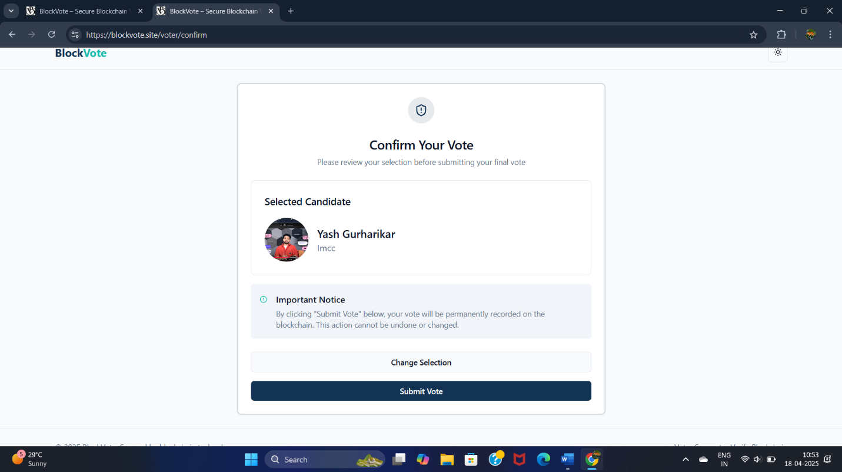

**Voting Page (Select Candidate and Vote)**

**Description:**  
This interface allows voters to view candidates and cast their vote for one of them.

**Key Features:**

**Candidate Display Cards:**

* Shows profile picture, name, party, and qualification.
* Only one candidate can be selected (radio-button or card toggle).

**Vote Submission:**

* “Cast Vote” button activates only after a selection.
* Backend records vote and generates blockchain hash.

**Validation Rules:**

* Only one candidate can be selected.
* Double voting prevented by backend flag.

**Security Measures:**

* Voter session tracked; prevents repeated votes.
* Votes go through a backend API that encrypts and stores the transaction.

**User Feedback:**

* Error messages for selection issues or network delays.

**Blockchain transaction Hash generated**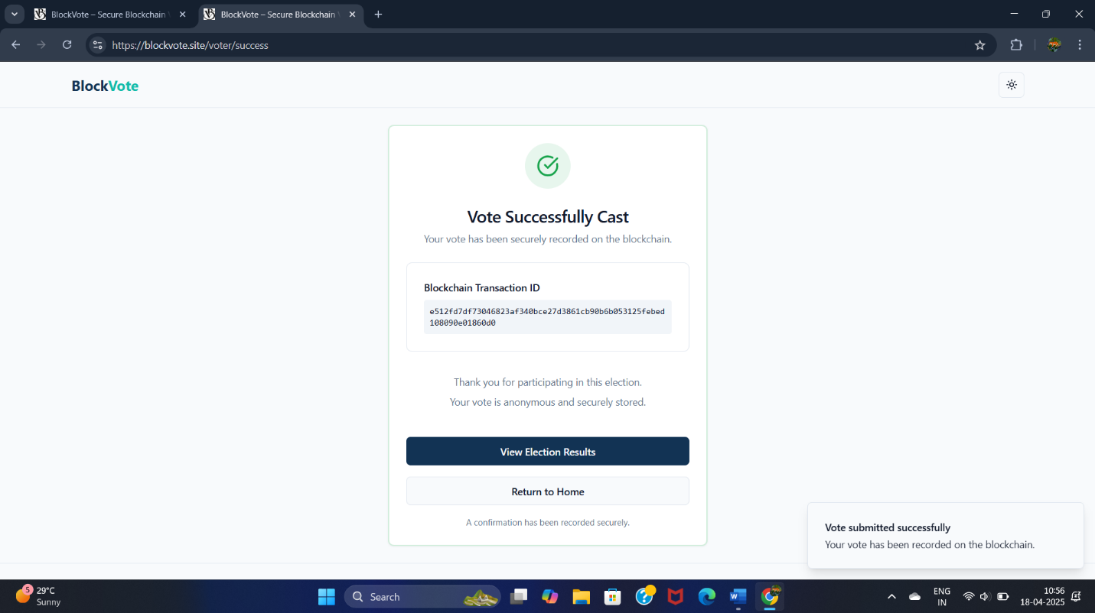



**Blockchain Transaction Hash Generated**

**Description:**  
Once a vote is cast, the system returns a unique blockchain transaction hash as a record of the vote on Stellar.

**Key Features:**

**Transaction Details:**

* Hash is shown in a read-only field.
* Includes a “Copy” button for convenience.

**Validation Rules:**

* Hash must be returned from a successful transaction.
* No hash is shown if vote fails.

**Security Measures:**

* Vote stored immutably; hash is generated only on confirmed submission.
* Ensures tamper-proof voting integrity.

**User Feedback:**

* “Vote recorded successfully on blockchain.”
* Button to go to home Page or view Result (result display on when voting is over).

**Live Voting update(Admin accessible only)**

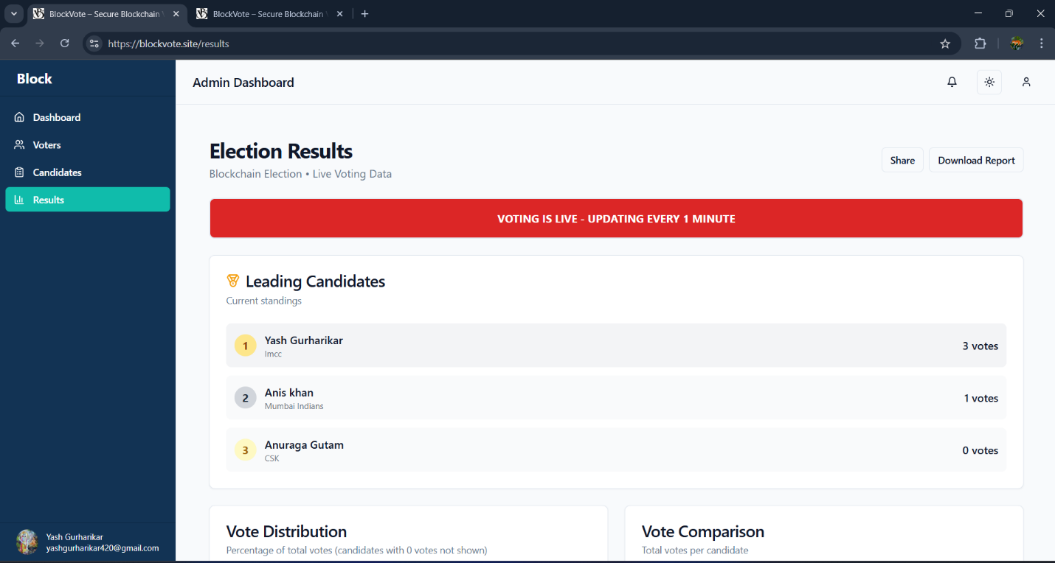

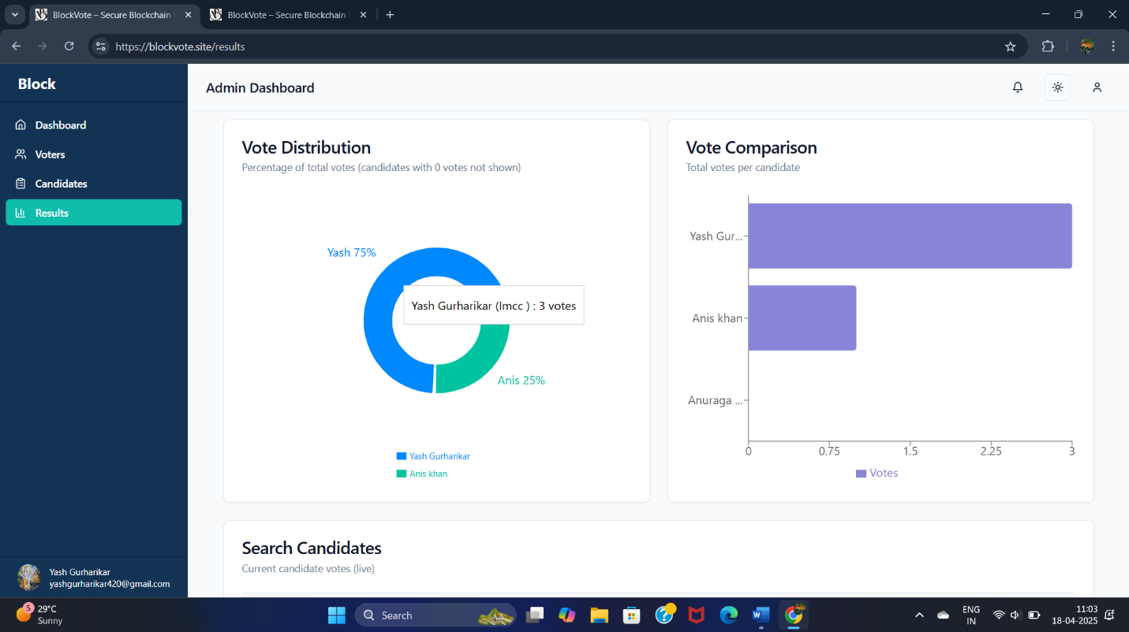



**Live Voting Update (Admin Only)**

**Description:**  
This dashboard is accessible only by the admin and displays live statistics of votes during the active voting phase.

**Key Features:**

**Live Charts and Graphs:**

* Bar chart showing vote count per candidate.
* Pie chart visualizing vote share.

**Voting Metrics:**

* Total votes cast.
* Percentage of registered voters who have voted.

**Validation Rules:**

* Only available when voting phase is active.
* Real-time data fetched every minute.

**Security Measures:**

* Admin token required to access.
* Read-only data to prevent tampering.

**User Feedback:**

* Live updates, color-coded charts, and tooltips.
* Auto-refresh indicator.

**Link to Stellar(To verify votes on blockchain)**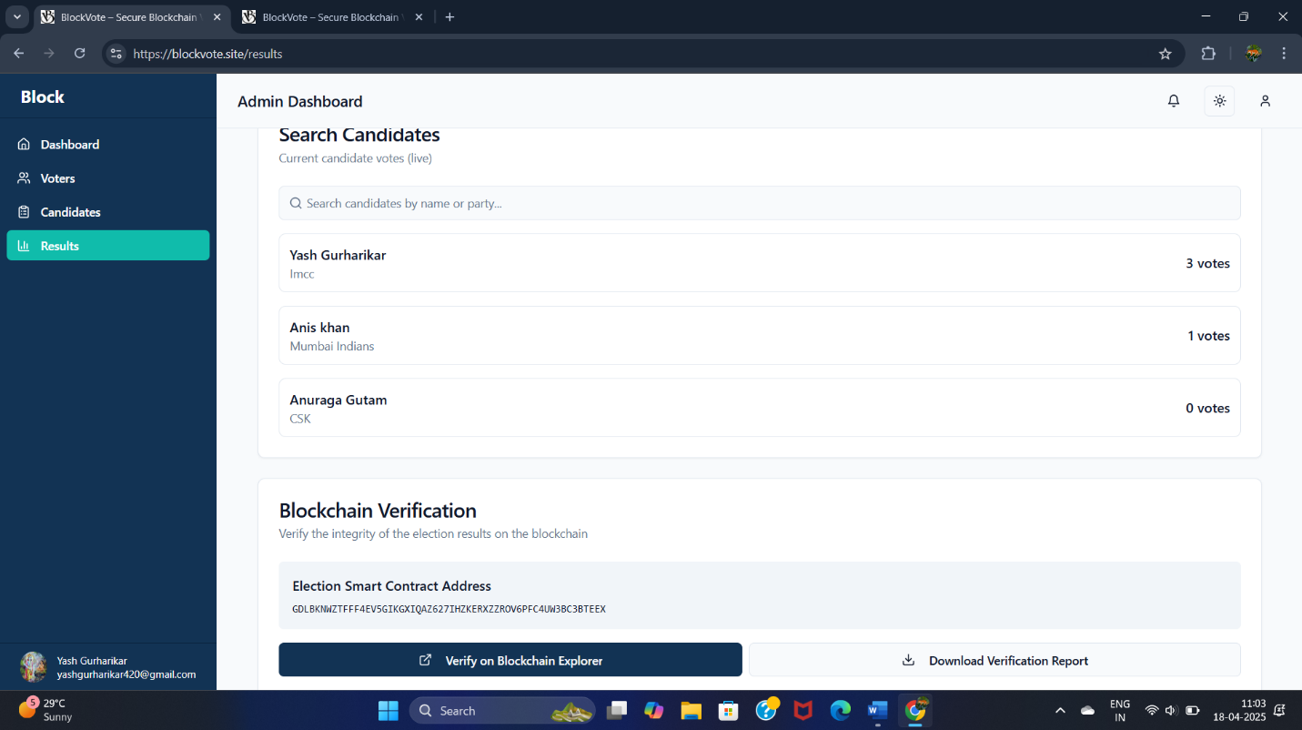



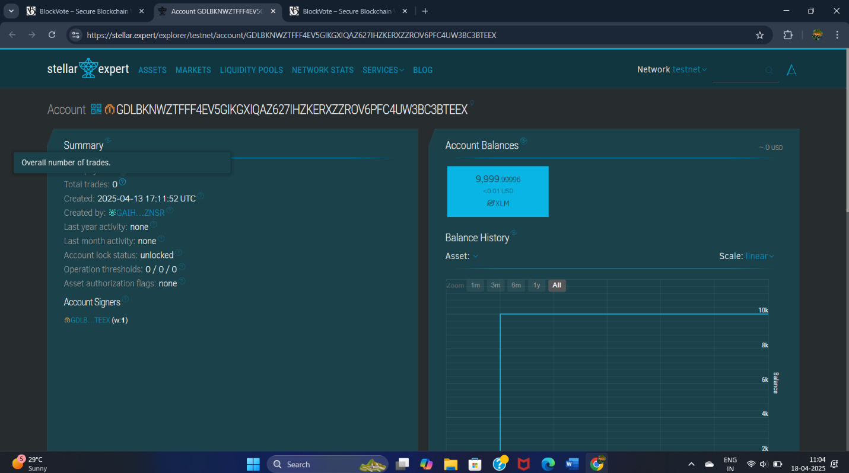

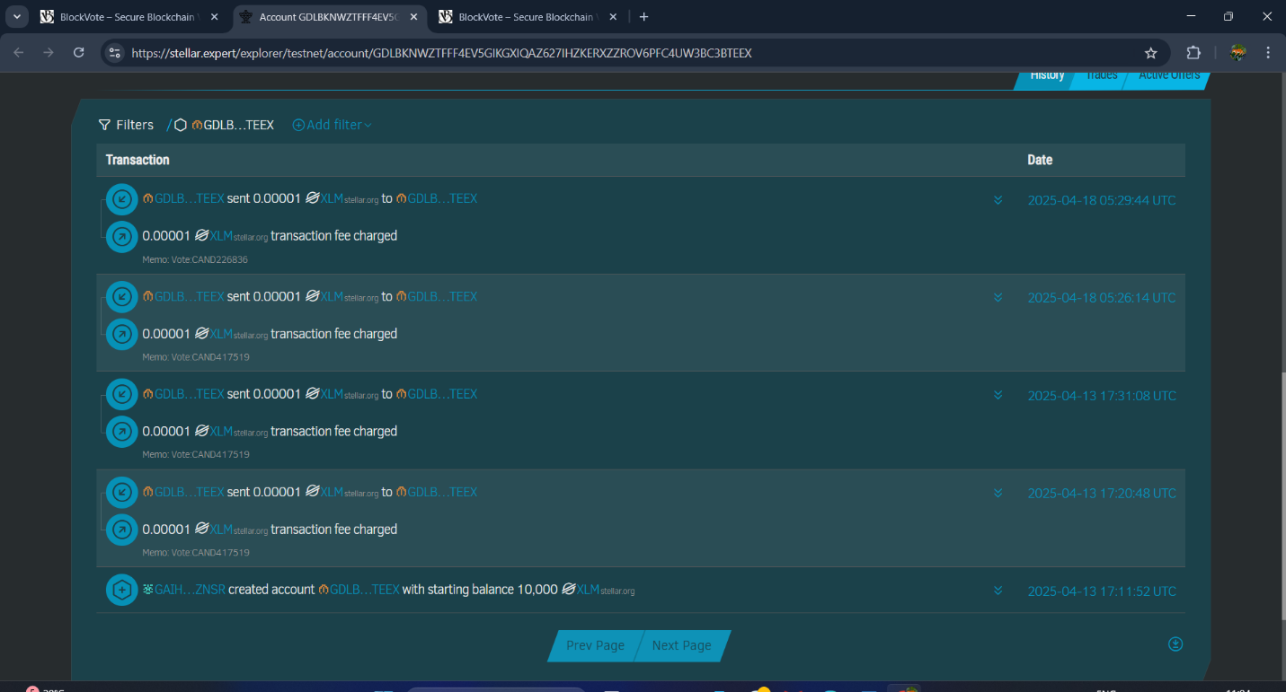

**Link to Stellar (To Verify Vote on Blockchain)**

**Description:**  
A direct external link that allows users or admins to verify the blockchain transaction on Stellar’s public ledger.

**Key Features:**

**Verification Options:**

* Clickable hash opens Stellar explorer in new tab.
* Displays transaction details like timestamp and sender account.

**Validation Rules:**

* Hash must be valid and from current election.
* Link works only if transaction has been confirmed.

**Security Measures:**

* Uses Stellar’s secure public API for data.
* Cannot be altered or redirected.

**User Feedback:**

* Clear prompt: “View Your Transaction on Blockchain.”
* Opens transaction in explorer instantly.

**Phase change to Result Phase(Otp Verification)**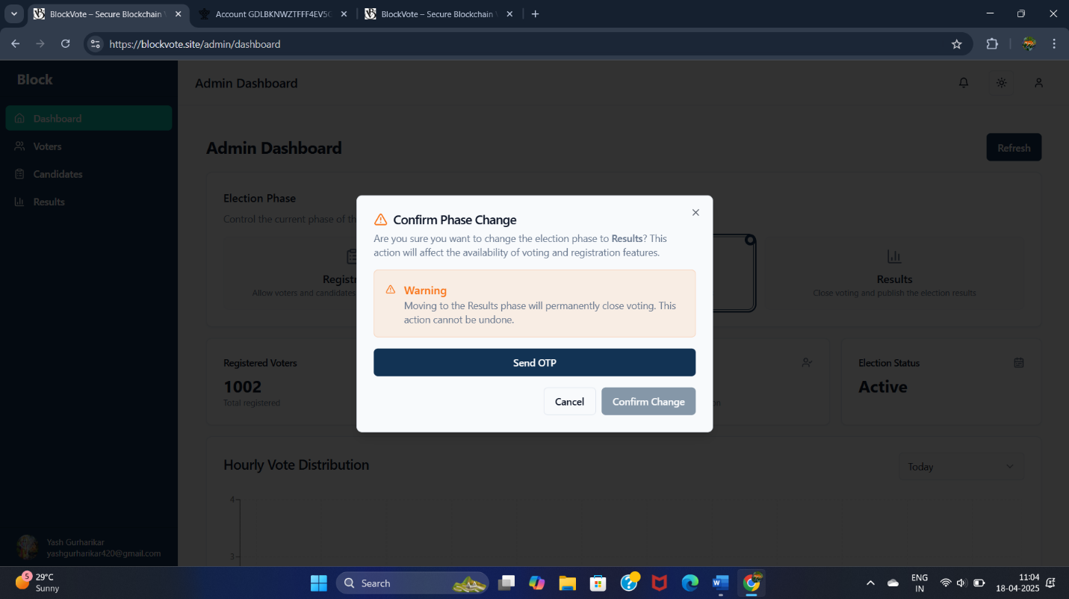

**Phase Change to Result Phase (OTP Verification)**

**Description:**  
After voting concludes, this page lets the admin enter OTP to transition the system to the result phase.

**Key Features:**

**OTP Input Field:**

* Used to securely authenticate admin action.

**Result Activation Logic:**

* System marks voting as closed and enables public result view.

**Validation Rules:**

* OTP must be valid and not reused.
* Phase change only allowed after all votes are cast.

**Security Measures:**

* All transitions are logged.
* OTP storage and validation via secure backend mechanism.

**User Feedback:**

* “Results are now live.”
* Confirmation email may also be sent to admin.

**Link to view Result (For Public)**

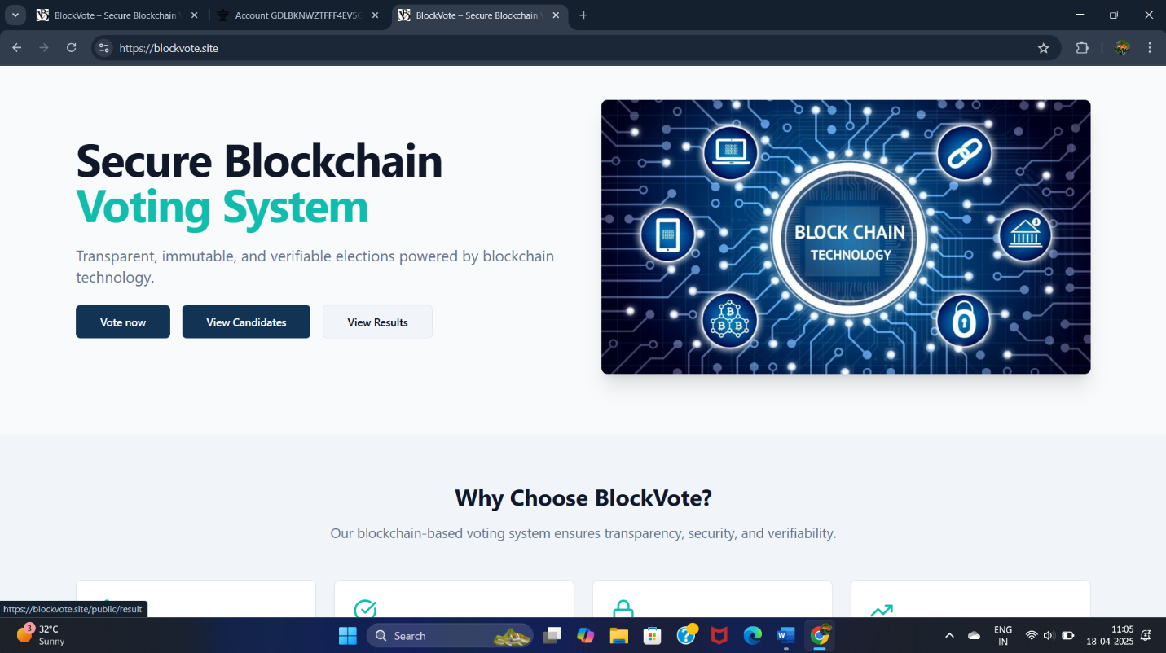



**Link to View Result (Public)**

**Description:**  
Once results are made public, this link lets any user view live or final results without login.

**Key Features:**

**Result URL:**

* Publicly accessible page showing election outcome.

**Data Presentation:**

* Vote count per candidate, graphs, and winner badge.

**Validation Rules:**

* Works only when result phase is active.
* Auto-refreshes for real-time viewing.

**Security Measures:**

* Read-only data pulled from blockchain or backend cache.

**User Feedback:**

* Shows message: “These are official results from BlockVote.”

**Select Admin and Display Result ( Only when Result is Out By Admin)**

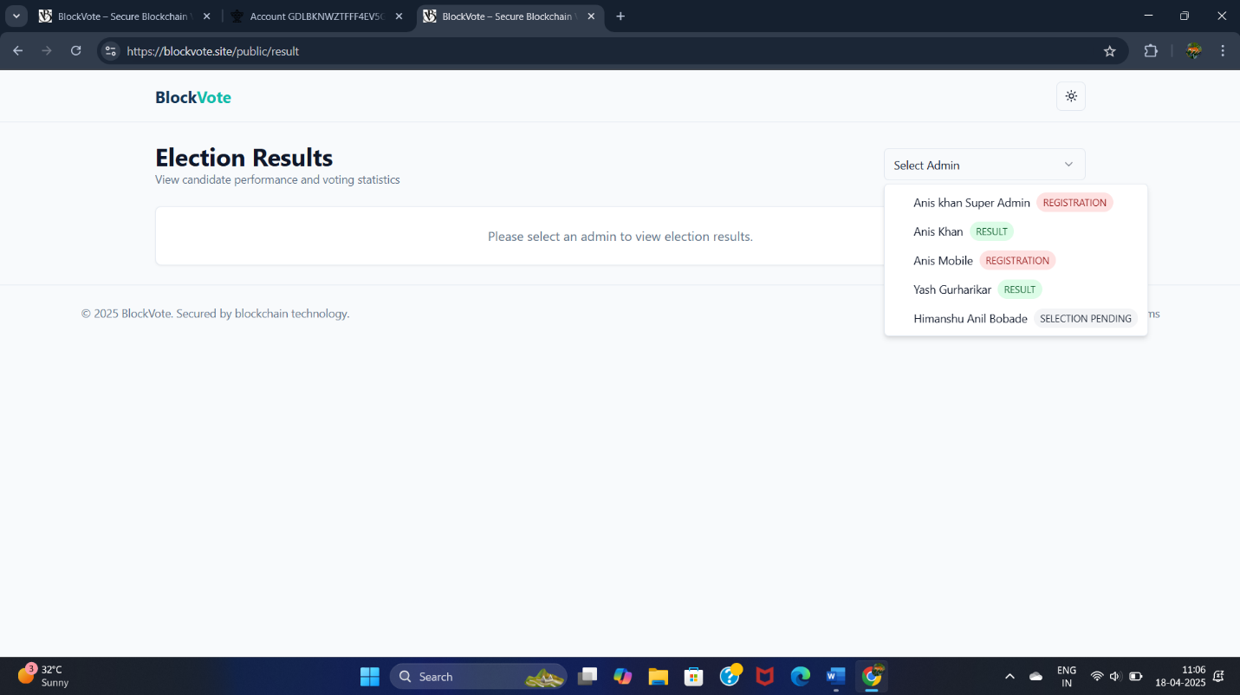



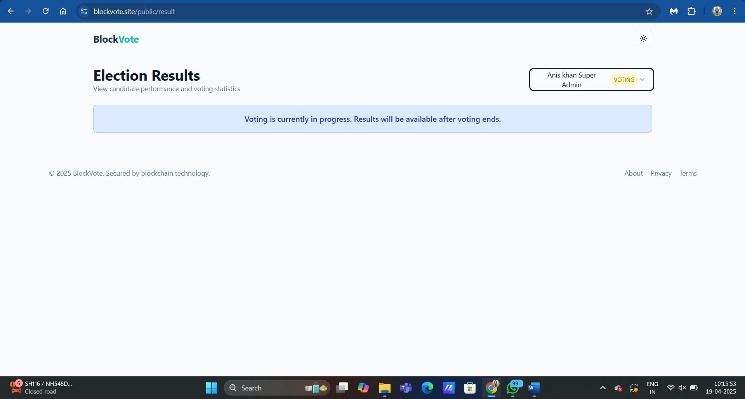

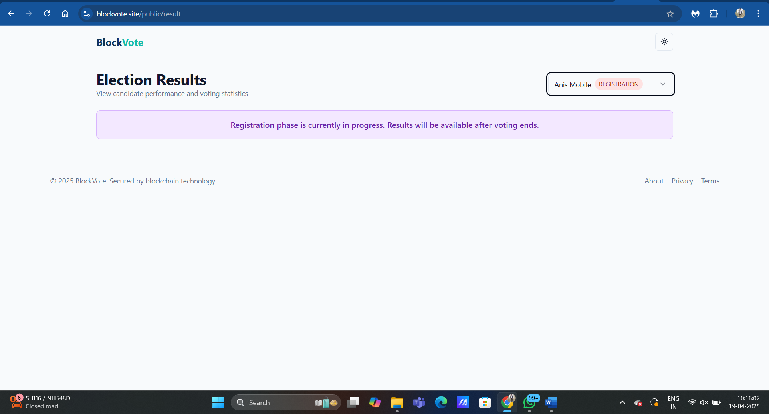

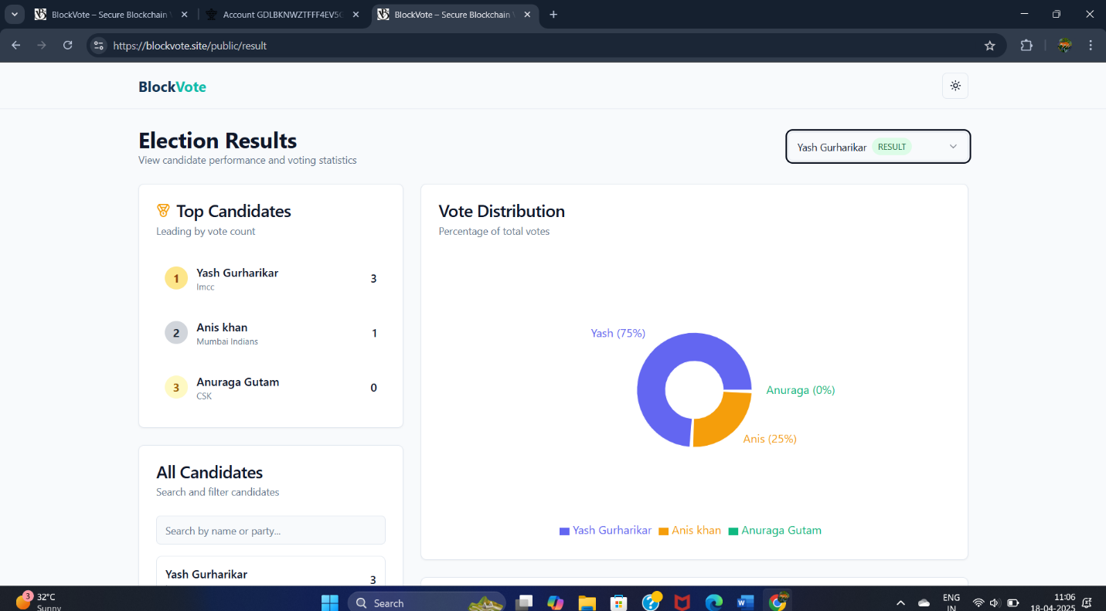

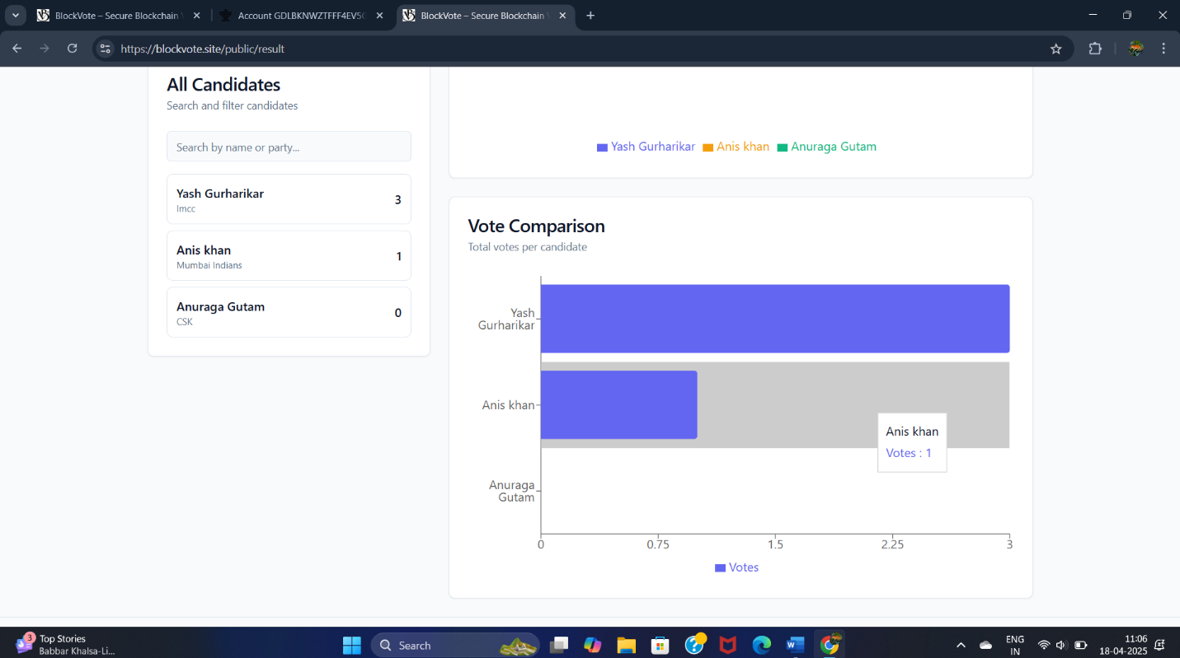

**Select Admin and Display Result ( Only when Result is Out By Admin)**

**Description:**  
Visitors select an admin (election organizer) and see the results for that particular election.

**Key Features:**

**Dropdown Selector:**

* List of all registered election admins.

**Result Display:**

* Shows vote counts and winner(s) for selected admin.

**Validation Rules:**

* Dropdown options dynamically fetched.
* Results only visible if admin’s phase is “Results.”

**Security Measures:**

* Prevents access to non-result elections.
* Public but protected against injection.

**User Feedback:**

* Charts, tables, and winner display update live.

**Public Page to View Candidates of Particular Admin**

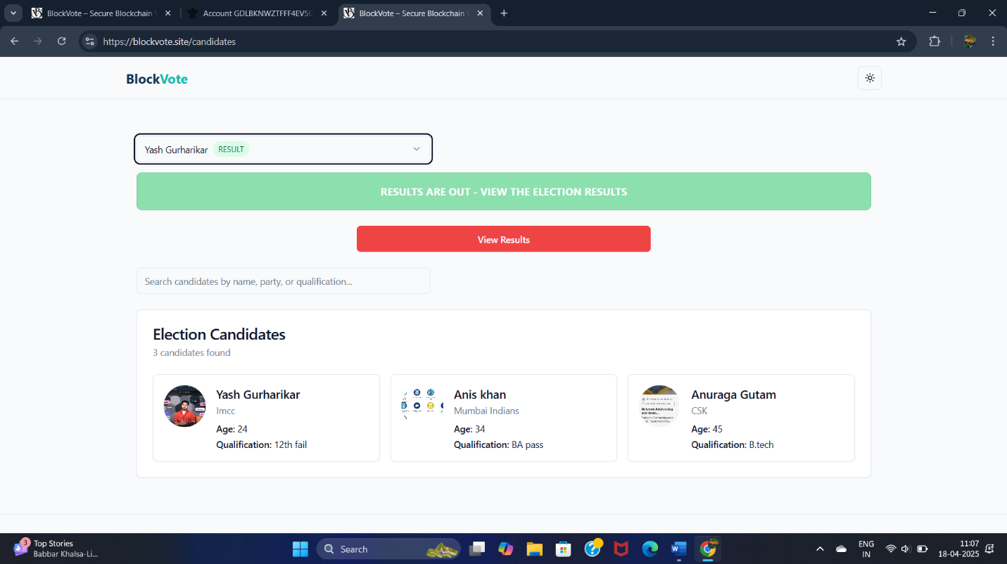

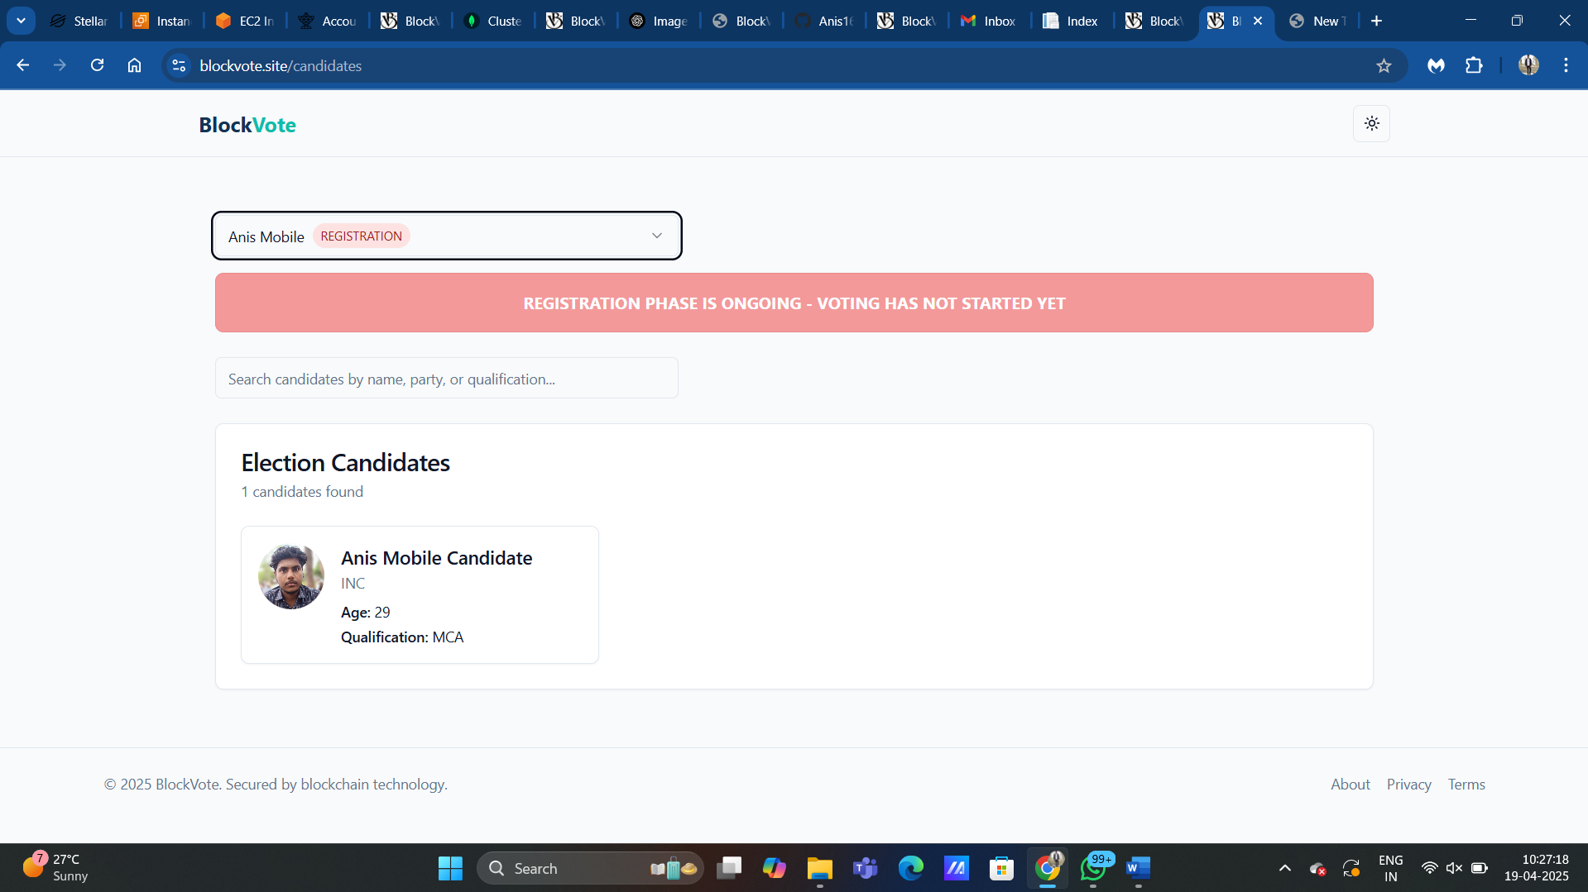

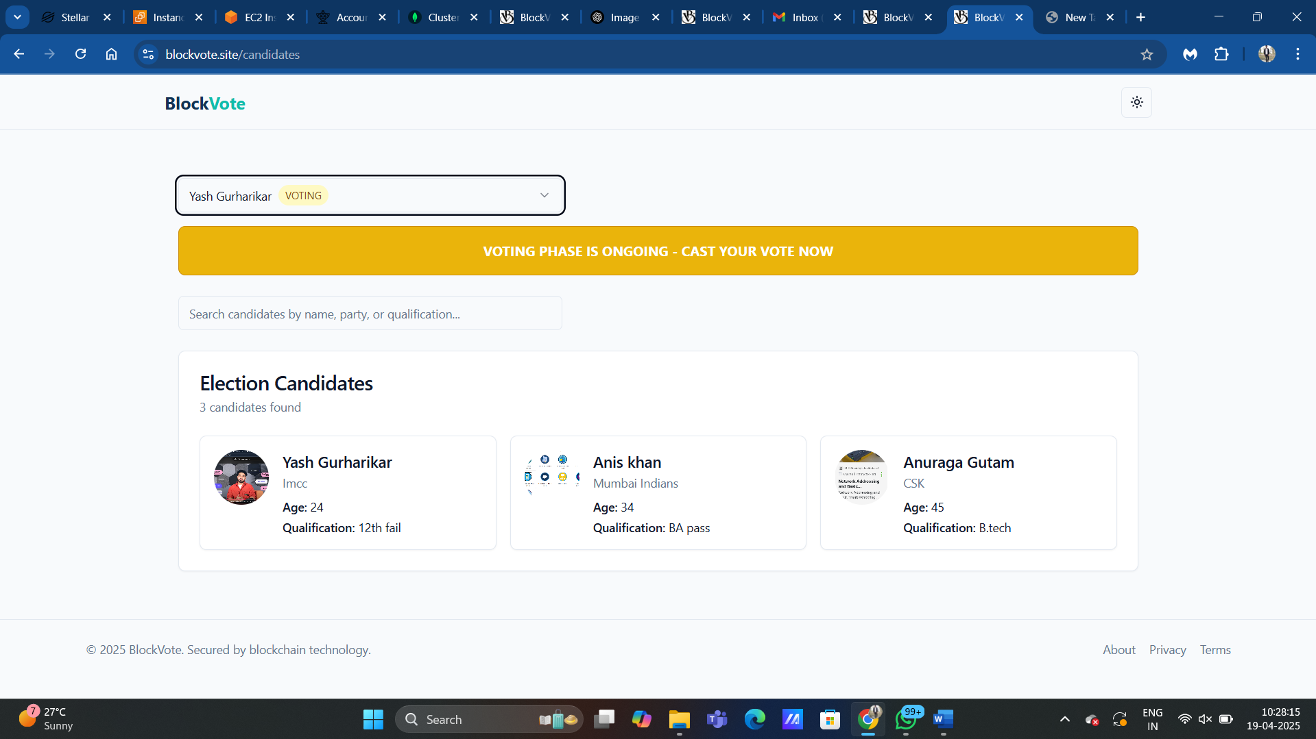

**Public Page to View Candidates**

**Description:**  
This page displays all candidates to public users before voting begins, encouraging transparency.

**Key Features:**

**Candidate Cards:**

* Picture, name, party, and short bio or qualification.

**Search & Filter:**

* Filter candidates by city, party, or name.

**Validation Rules:**

* Only approved candidates shown.
* Cards are read-only.

**Security Measures:**

* No interactive elements that allow changes.
* Fetched from verified backend source.

**User Feedback:**

* “View All Contesting Candidates” heading with clear layout.

**Otp Verification Mail**

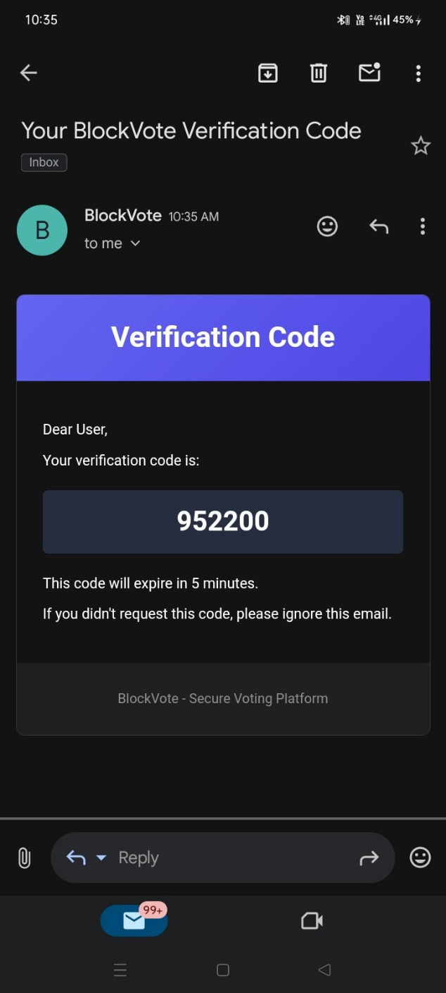 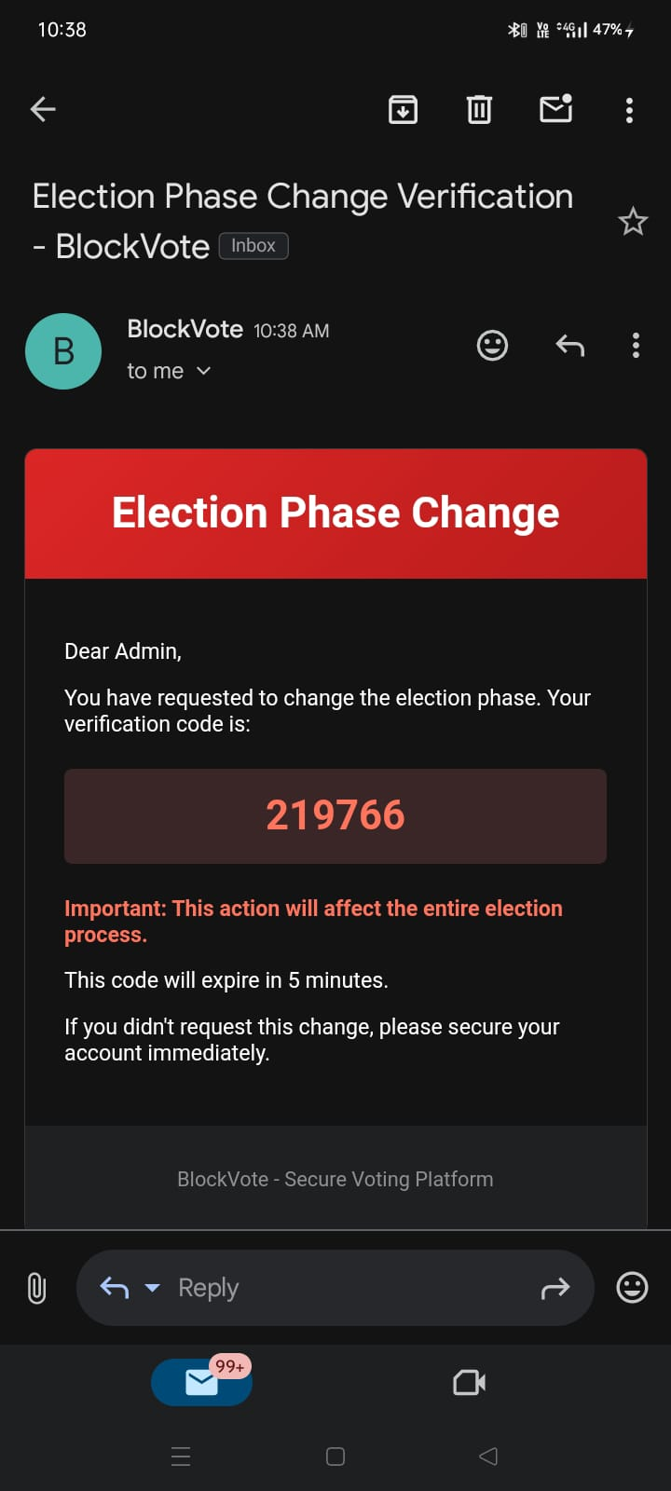

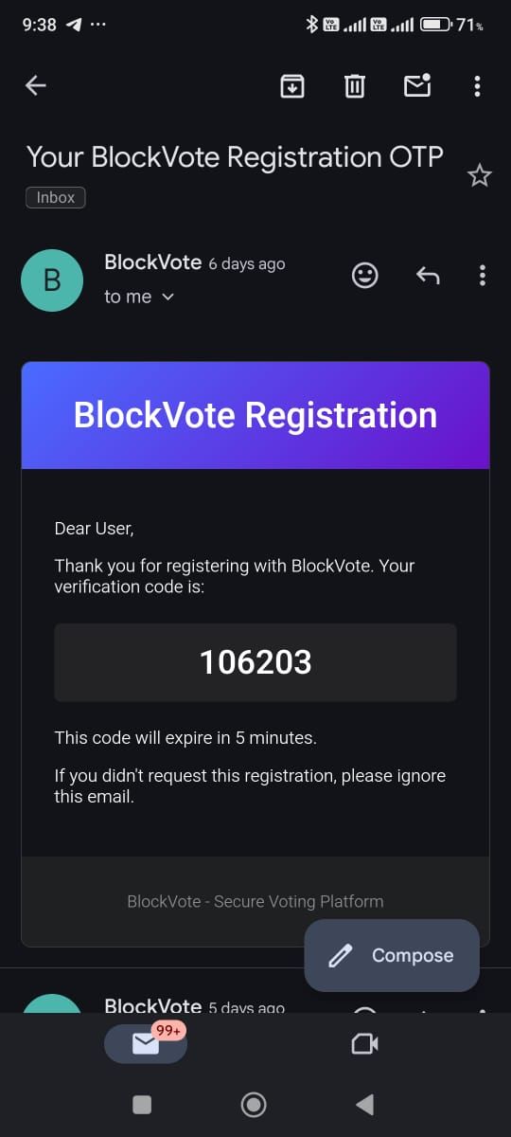 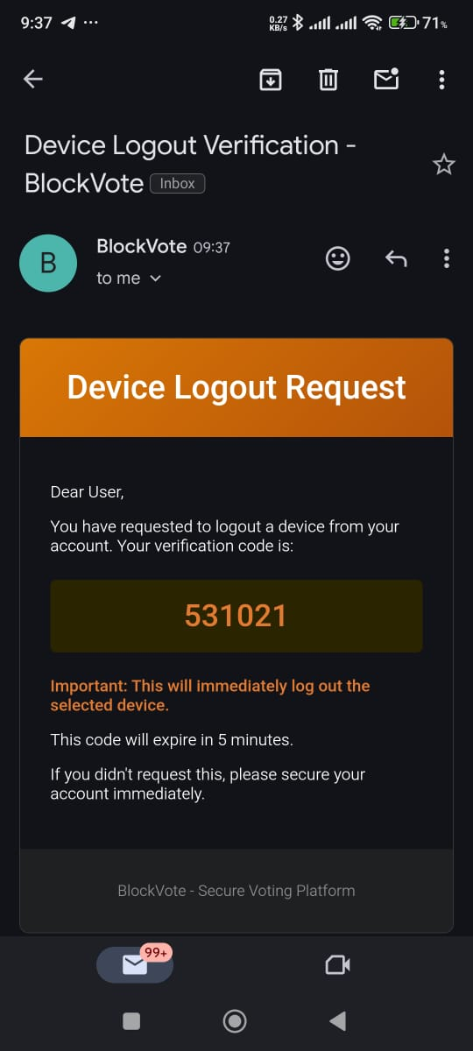

**Contact Details of the Students:**

|  |  |  |  |
| --- | --- | --- | --- |
| **Roll No** | **Name** | **E-Mail ID** | **Contact Number** |
| 2401098 | Anis Khan | aniskhan20171@gmail.com | 8779530570 |
| 2401064 | Yash Gurharikar | yashgurharikar420@gmail.com | 8830696094 |